Crack the Code | Direct Proportion

A | $y$ is directly proportional to $x$. When $x=12, y=300$. The formula linking $y$ and $x$ is  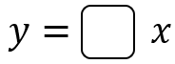 | B | $a$ is directly proportional to $b^{2}$. When $b=5, a=450$. The formula linking $a$ and $b$ is  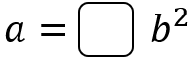
C | $s$ is directly proportional to $t$. When $t=10, s=\frac{1}{2}$. Find the value of $s$ when $t=80$. | D | $y$ is directly proportional to $x^{3}$. When $x=4, y=1280$. The formula linking $y$ and $x$ is  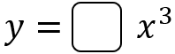
E | $a$ is directly proportional to $\sqrt{b}$. When $b=49, a=28$. The formula linking $a$ and $b$ is  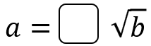 | F | $c$ is directly proportional to the square of $d$. When $d=3, c=45$. Find the value of $c$ when $d=6$.
G | $f$ is directly proportional to the cube of $g$. When $g=10,$  $f=2500$. Find the value of $f$ when $g=4$. | H | $p$ is directly proportional to $\sqrt[3]{t}$. When $t=512, p=120$. The formula linking $p$ and $t$ is  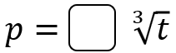
I | The mass $M$ in grams of a mouse is directly proportional to its length $L$ in cm. A mouse with length $20 cm$ has a mass $30 g$. Find the length of a mouse with a mass of $48 g$. | J | $y$ is directly proportional to the square root of $x$. When $x=9,$  $y=42$. Find the value of $y$ when $x=225$.
K | $w$ is directly proportional to the cube root of $v$. When $v=729,$  $w=22.5$. Find the value of $v$ when $w=10$. | L | $a$ is directly proportional to $b^{3}$.  $b$ is directly proportional to the square root of $c$. When $c=16,$  $a=448$. Find the value of $c$ when $a=1512$
To get the three-digit code, add all your answers together.

