Fill in the Blanks | Tree Diagrams for Dependent Events

Question | Tree Diagram | Probability
There are $x$ blue counters and 4 red counters in a bag. Two counters are chosen at random without replacement. Complete the tree diagram and find expressions for each of the probabilities. | 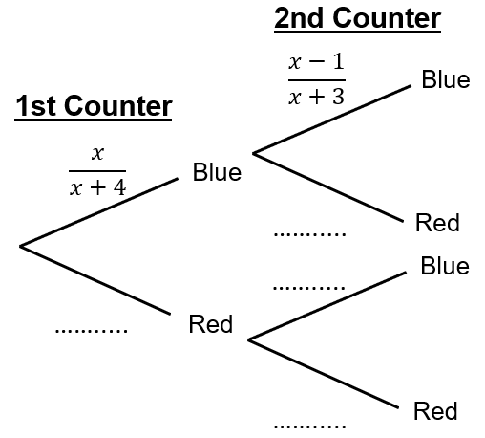 | $$P\left(BB\right)= \frac{x}{x+4} × \frac{x-1}{x+3}$$
 |  | $$P\left(BR\right)= ×$$
 |  | $$P\left(RB\right)= ×$$
 |  | $$P\left(RR\right)= ×$$
There are 8 black pens and $n$ green pens in a pencil case. Gloria chooses two pens at random from the pencil case. Complete the tree diagram and find expressions for each of the probabilities. | 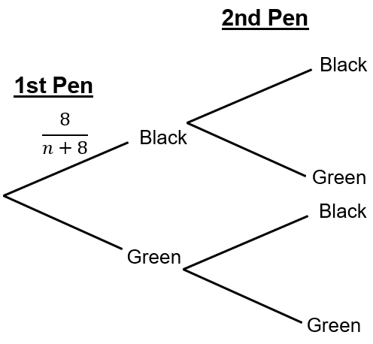 | $$P\left(BB\right)= \frac{8}{n+8} ×$$
 |  | $$P\left(BG\right)= ×$$
 |  | $$P\left(GB\right)= ×$$
 |  | $$P\left(GG\right)= ×$$
There are $n$ biscuits in a tin. There are some digestives and five shortbreads. Ayyan takes two biscuits from the tin at random and eats them. Draw a tree diagram and find expressions for each of the probabilities. |  | $$P\left(DD\right)= ×$$
 |  | $$P\left(DS\right)= ×$$
 |  | $$P\left(SD\right)= ×$$
 |  | $$P\left(SS\right)= ×$$
A jar contains $x$ lime sweets and some pear sweets. The number of pear sweets is one more than the number of lime sweets. Two sweets are chosen at random. Draw a tree diagram and find expressions for each of the probabilities. |  | $$P\left(LL\right)= ×$$
 |  | $$P\left(LP\right)= ×$$
 |  | $$P\left(PL\right)= ×$$
 |  | $$P\left(PP\right)= ×$$

