Fill in the Blanks | Tree Diagrams for Independent Events

Question | Tree Diagram | Probability
The probability of passing a music exam is 0.7. Diana and Dev both sit the music exam. Complete the tree diagram and calculate the probability of each outcome. | 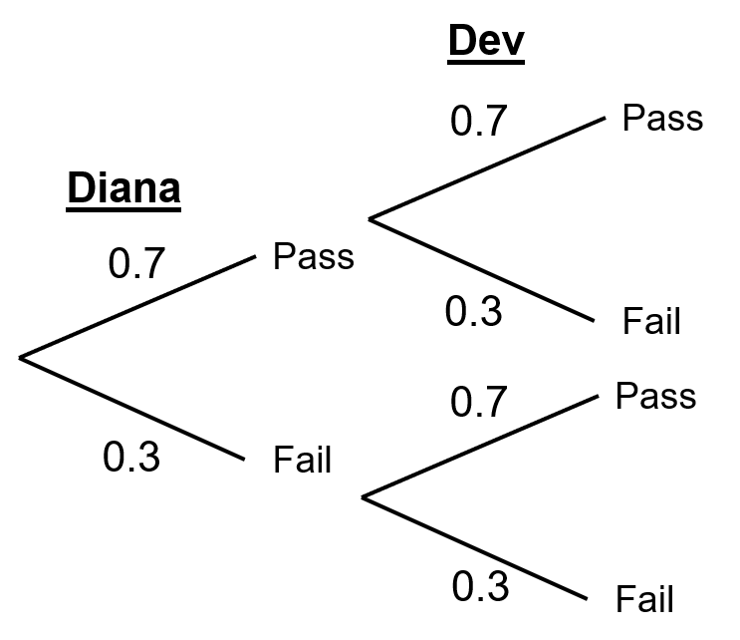 | $$P\left(PP\right)=0.7×0.7=$$ | $$0.49$$
 |  | $$P\left(PF\right)=0.7×0.3=$$
 |  | $$P\left(FP\right)=0.3×0.7=$$
 |  | $$P\left(FF\right)=0.3×0.3=$$
The probability of a biased coin landing on tails is 0.4. The coin is tossed twice. Complete the tree diagram and calculate the probability of each outcome. | 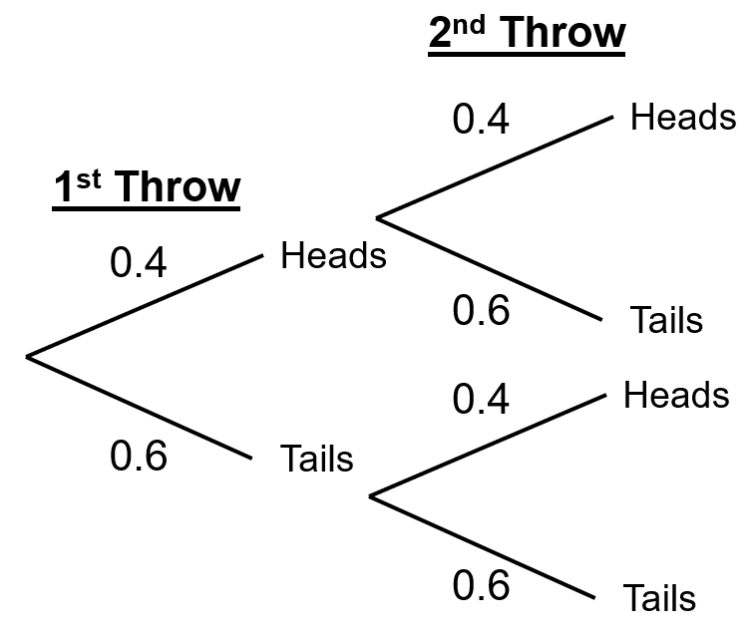 | $$P\left(HH\right)=0.4×0.4=$$
 |  | $$P\left(HT\right)= × =$$
 |  | $$P\left(TH\right)= × =$$
 |  | $$P\left(TT\right)= × =$$
The probability of Abby being late for work is $\frac{1}{6}$. Abby works Monday and Tuesday. Complete the tree diagram and calculate the probability of each outcome. | 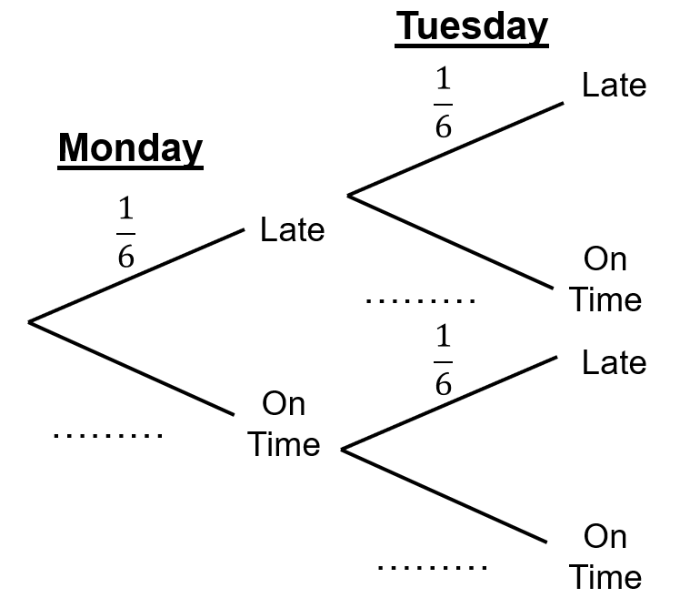 | $$P\left(LL\right)= × =$$
 |  | $$P\left(LO\right)= × =$$
 |  | $$P\left(OL\right)= × =$$
 |  | $$P\left(OO\right)= × =$$
The probability of stopping at traffic lights is $\frac{3}{8}$. Jameela drives through two sets of traffic lights. Complete the tree diagram and calculate the probability of each outcome. | 