Equation of a Straight Line Revision
(a) | (b) |  | (c) |  | (d)
Write down the gradient and  y-intercept of the straight line with equation $y=5x-2$ | Write down the gradient and  y-intercept of the straight line with equation $y=-\frac{1}{2}x+7$ |  | Write down the gradient and y-intercept of the straight line with equation $3y=2x-9$ |  | Find the gradient of the line joining $(2, 5)$ and $(4, 11)$
(e) | (f) |  | (g) |  | (h)
Find the equation of the line.  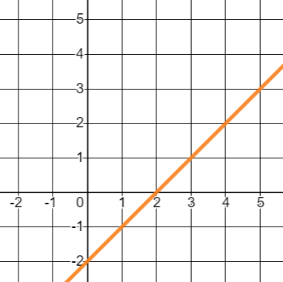 | Find the equation of the line.  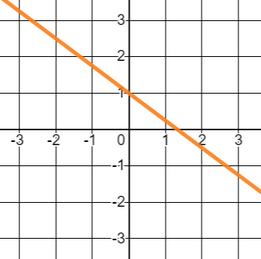 |  | Write down the equation of the line that is parallel to  $y=-4x-9$ and passes through $(0, 2)$ |  | Write down the equation of the line that is perpendicular to  $y=-3x$ and passes through the point $(0, -5)$
(i) |  | (j) |  | (k)
Find the equation of the line that has a gradient of $2$ and passes through $(4, 3)$ |  | Find the equation of the line that is perpendicular to the line $2y=x-8$ and passes through $(-1, 9)$ |  | Find the equation of the line that passes through $(2, 9)$ and $(5, 3)$.

