Solving Trigonometric Equations Using Graphs
Use your calculator and the trigonometric graphs to find all values of the angle between 0º and 360º
$$y=\sin{x}$$ |  | $$y=\cos{x}$$ |  | $$y=\tan{x}$$
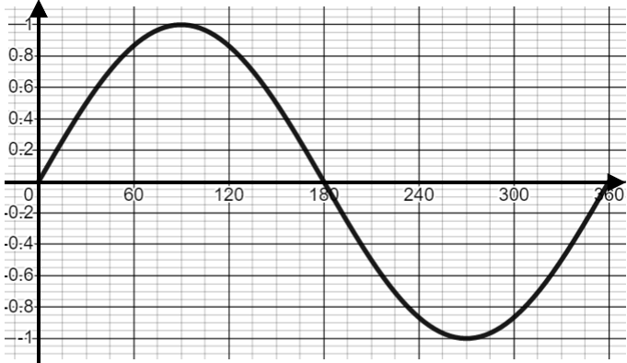 |  | 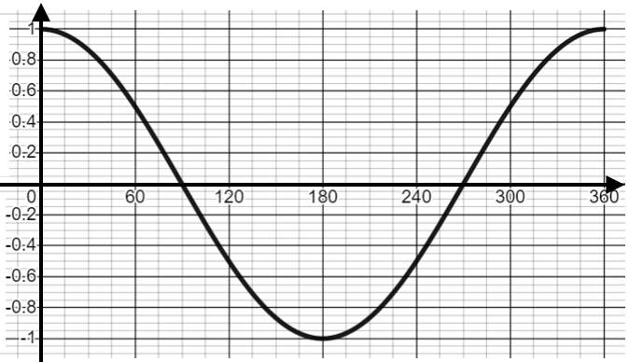 |  | 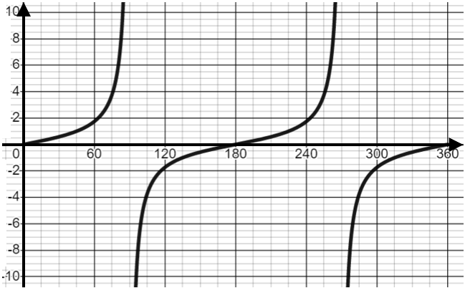
$$\sin{x}=0.3$$ | $$\cos{x}=0.9$$ |  | $$\tan{x}=3.2$$ |  | $$\cos{x}=0.6$$
$$\sin{x}=0.8$$ | $$\cos{x}=0.15$$ |  | $$\tan{x}=8$$ |  | $$\sin{x}=0.43$$
$$\cos{x}=0.37$$ | $$\sin{x}=0.285$$ |  | $$\tan{x}=0$$ |  | $$\cos{x}=1$$
$$\sin{x}=0.5$$ | $$\tan{x}=1$$ |  | $$\sin{x}=1$$ |  | $$\cos{x}=0$$

