Geometry Revision |  |  |  | 6
(a) | (b) | (c) | (d)
A cuboid has dimensions $4 cm$ by $9 cm$ by $12 cm$. Find the length of the diagonal AB to 1 decimal place.  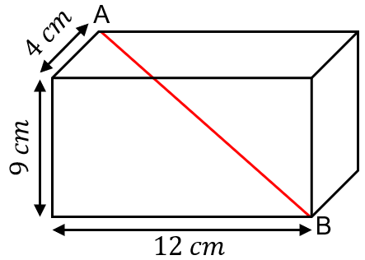 | Find the value of angle $x$. Give reasons for your answers.  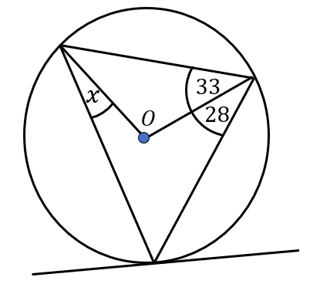 | 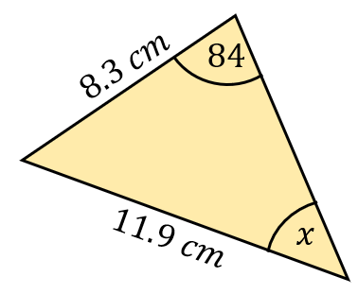  Calculate the value of angle $x$. giving your answer to 1 decimal place. | The two cylinders A and B are similar. The surface areas of A and B are $24 {cm}^{2}$ and $73.5 {cm}^{2}$ respectively. Given the volume of cylinder B is $171.5 {cm}^{3}$, find the volume of cylinder A.
(e) | (f) | (g) | (h)
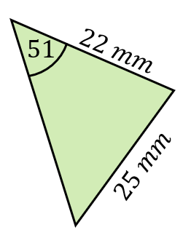  Find the area of the triangle shown, giving your answer to 3 significant figures. | Find the angle that the line $AG$ makes with the plane $EFGH$.  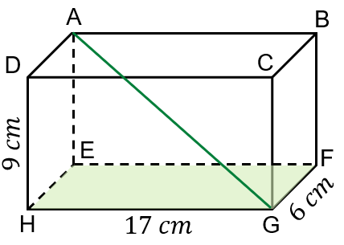 | AB and CD are chords of the circle. Find the missing value $x$.  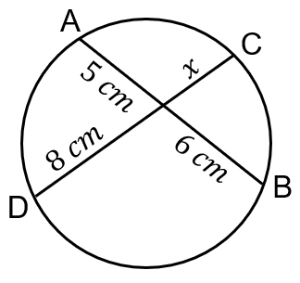 | $\vec{OA}=a$ $\vec{OB}=b$  $\vec{OB}=\vec{BE}$. C is the midpoint of OA. Given that CDE is a straight line, find $BD : DA$  