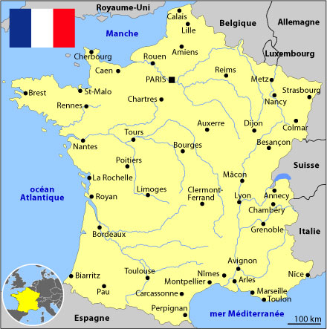
Tour De France Bearings
N
1 cm : 100 km
From | To | Bearing | Distance (km)
Lille |  | 143 | 290
 | Strasbourg
Strasbourg |  | 238 | 290
 | Grenoble
Grenoble |  | 139
 | Nimes
Nimes |  | 265 | 540
 | Bordeaux
Bordeaux |  | 348 | 400
 | Paris

