**Harder Compound Shapes**

Find the area and perimeter of each of these compound shapes, giving your answers to 1 decimal place.

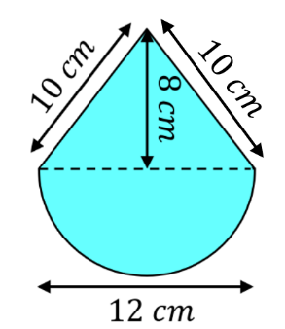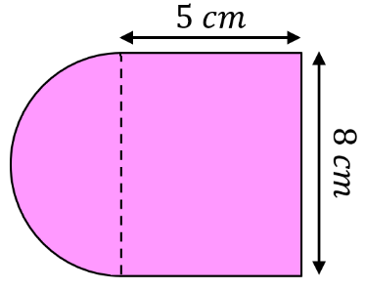 (a) (b)

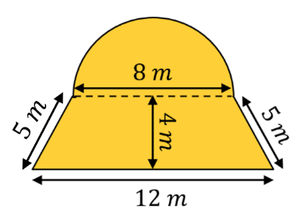

(c)

Find the area and perimeter of each of these compound shapes, giving your answers to 1 decimal place.

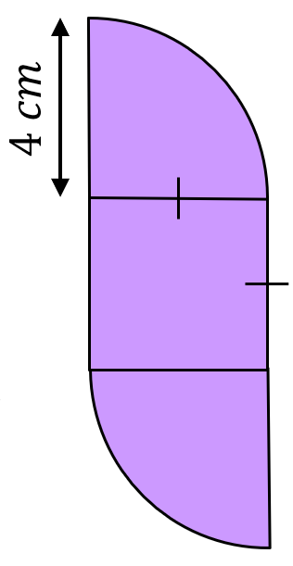

(a) (b)

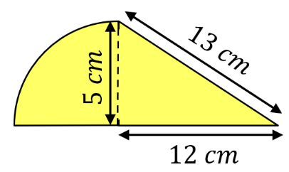

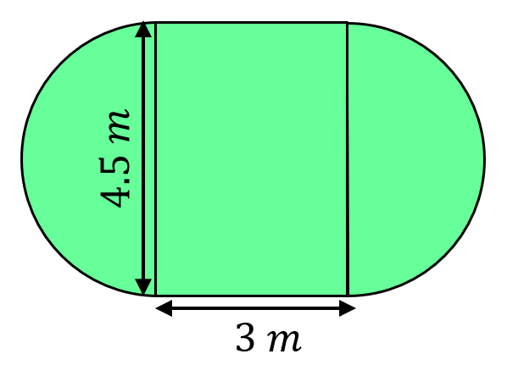The plan of a lawn is shown below. A gardener wants to re-turf the lawn and add a fence around the perimeter of the lawn. Turf costs £4.75 per m2 and fencing costs £9 per metre. How much will it cost?

**Harder Compound Shapes**

Find the area and perimeter of each of these compound shapes, giving your answers to 1 decimal place.

 (a) (b)



(c)

Find the area and perimeter of each of these compound shapes, giving your answers to 1 decimal place.



(a) (b)



The plan of a lawn is shown below. A gardener wants to re-turf the lawn and add a fence around the perimeter of the lawn. Turf costs £4.75 per m2 and fencing costs £9 per metre. How much will it cost?