Fill in the Blanks | Equations of Straight Lines

Graph | Points on Line |  | Graph | Points on Line
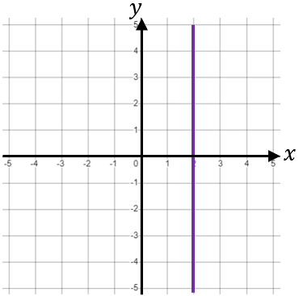 | $$(2, 1)$$ |  | 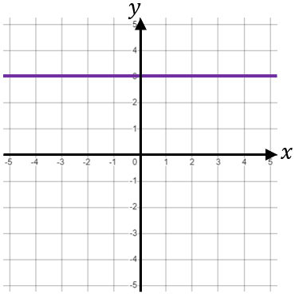 | $$(1, 3)$$
 | $$(2, 0)$$
 | $$(2, -4)$$
 | Equation |  |  | Equation
Graph | Points on Line |  | Graph | Points on Line
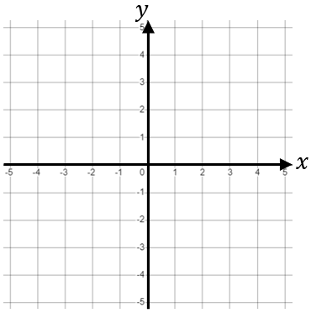 | $$(3, 1)$$ |  |  | $$(-2, 4)$$
 | $$(-1, 1)$$
 | Equation |  |  | Equation
 | $$y=1$$ |  |  | $$x=-2$$
Graph | Points on Line |  | Graph | Points on Line
 | $$(0, 3)$$
 | $$(0, -1)$$
 | Equation |  |  | Equation
 |  |  |  | $$y=-2.5$$
Graph | Points on Line |  | Graph | Points on Line
 | $$(2, 2)$$
 | $$(5, 5)$$
 | $$(-1, -1)$$
 | Equation |  |  | Equation
 |  |  |  | $$y=-x$$

