Finding the Length of a Short Side

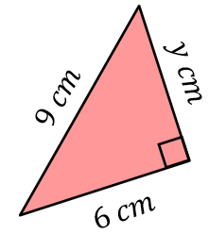
Find each of these lengths, rounding to 1 decimal place when necessary.
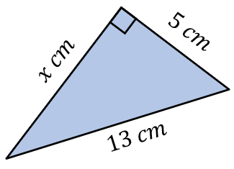
(a) (b)

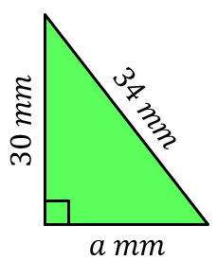
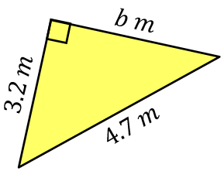
(c) (d)

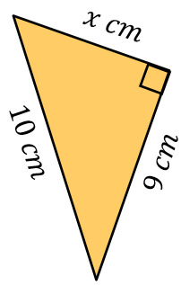
Find each of these lengths, leaving your answer in surd form.
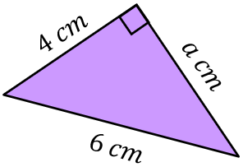
(a) (b)

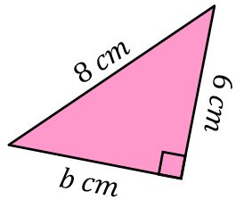
(c) (d)
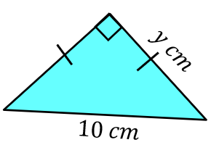

Find the missing lengths, rounding your answers to 3 significant figures.
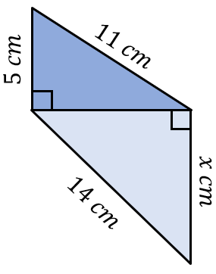
(a) (b)
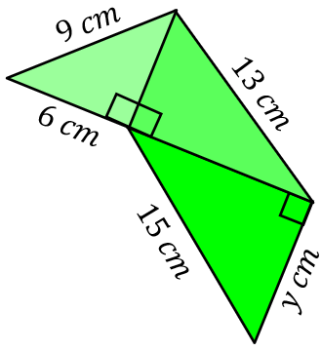

Finding the Length of a Short Side

Find each of these lengths, rounding to 1 decimal place when necessary.
(a) (b)

(c) (d)

Find each of these lengths, leaving your answer in surd form.
(a) (b)

(c) (d)

Find the missing lengths, rounding your answers to 3 significant figures.
(a) (b)

