Fill in the Blanks | Rearranging Formulae

$$x=…$$ | Function Machine | $$y=…$$
$$x=2y+a$$ | 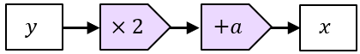 | $$y=\frac{x-a}{2}$$
 | 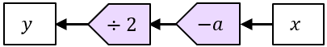
$$x=y^{2}-a$$ | 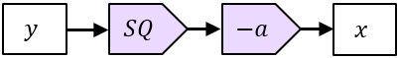
$$x=\frac{ay}{2}$$
$$x=\sqrt{y+b}$$
$$x=\frac{y}{2}-a$$
$$x=ay^{2}+b$$ | 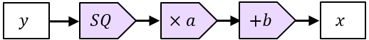
$$x=\frac{y^{2}-2}{b}$$
$$x=\frac{a\sqrt{y}}{b}$$
$$x=\frac{2y-b}{a}$$
$$x=2+by^{2}$$
$$x=b\sqrt{y+a}$$

