Using Pythagoras Theorem

Use Pythagoras’ Theorem to decide whether each of these triangles is right-angled. Explain your reasoning.
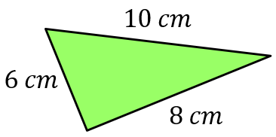
(a)

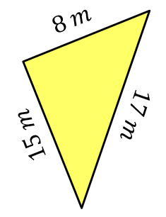
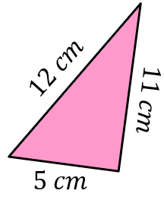
(b) (c)

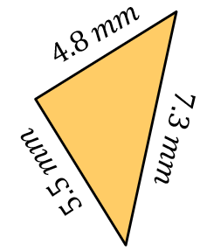
Decide whether each of these triangles is right-angled.
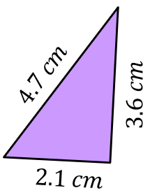
(a) (b)

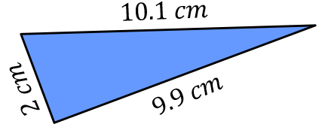
(c)

Which of these triangles is right-angled?
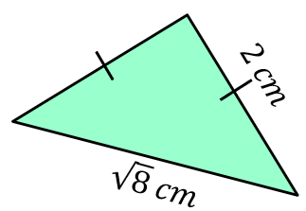
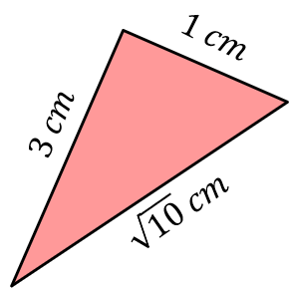
(a) (b)

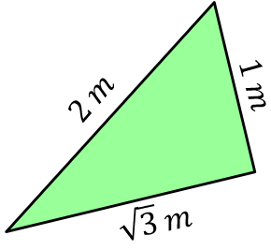
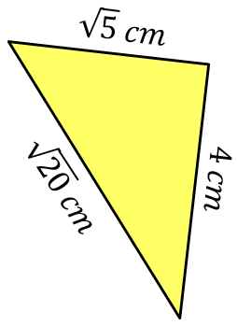
(c) (d)

Using Pythagoras Theorem

Use Pythagoras’ Theorem to decide whether each of these triangles is right-angled. Explain your reasoning.
(a)

(b) (c)

Decide whether each of these triangles is right-angled.
(a) (b)

(c)

Which of these triangles is right-angled?
(a) (b)

(c) (d)

