Shading and Describing Harder Graphical Inequalities
Shade the region that satisfies the inequalities $x≤4 y≥-1 y≤x$  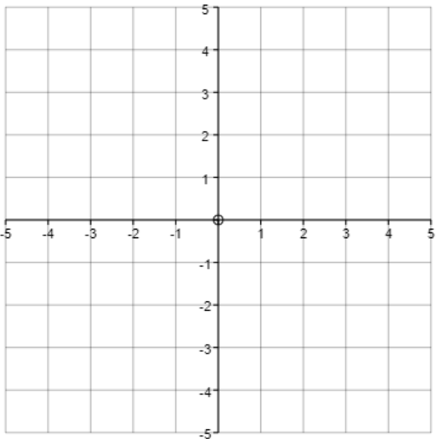 | Shade the region that satisfies the inequalities $x>-1 y≥0 x+y≤3$ | Shade the region that satisfies the inequalities $2x+3y<6 y≤x+2$  $$y>-1$$
Write down the inequalities which fully describe the shaded region.  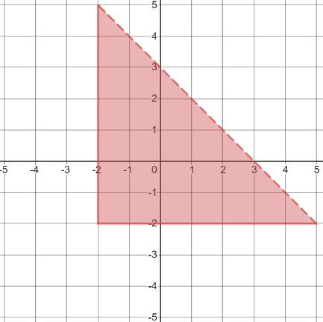 | Write down the inequalities which fully describe the shaded region.  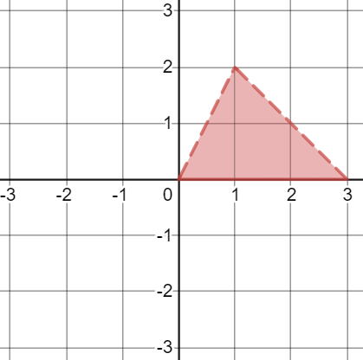 | Write down the inequalities which fully describe the shaded region.  