Geometry Revision |  |  |  | 1
(a) | (b) | (c) | (d)
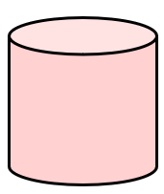  Write down the mathematical name for this 3D shape. | Convert $720$ centimetres into metres. | Write down the name for a five-sided polygon. | (i) Write down the mathematical name for the shaded part of the circle shown.  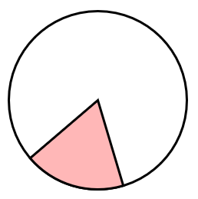  (ii) On the same diagram, draw a chord of the circle.
(e) | (f) | (g)
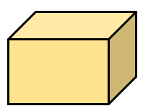  Write down the number of faces this 3D shape has. | Convert $5.4$ kilograms into grams. | 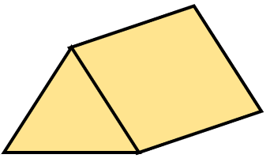  How many vertices does this 3D shape have?
(h) | (j) | (k) | (l)
In the space below, draw a line which is $4.2 cm$ long. | (i) What type of angle is the angle marked $x$?  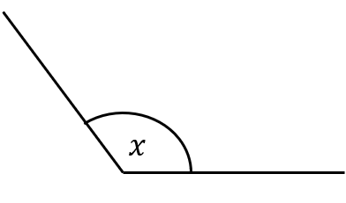  (ii) Measure the size of angle $x$. | (i) Find the size of angle $x$.  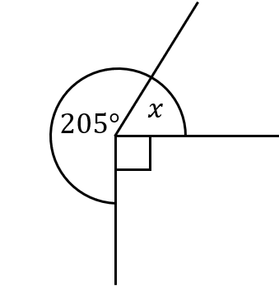  (ii) Give a reason for your answer. | (i) Write down the name given to this type of triangle.  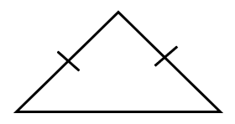  (ii) Write down the name given to this type of quadrilateral.  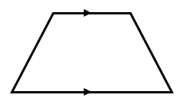
(i)
Convert $2700$ millilitres into litres.

