Experimental Probability
Find an estimate of the probability that a drawing pin will land point up
Throw the drawing pin at least 100 times and record the number of times it lands point up or point down. Record your results in the table below.
 | Tally | Total
Point Up
Point Down
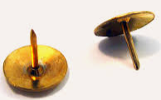 | Estimate of the probability of the drawing pin landing point down:

Find an estimate of the probability that a cuboctahedron lands on a square face
Roll the cuboctahedron at least 100 times and record the number of times it lands on a square face or a triangular face. Record your results in the table below.
 | Tally | Total
Square Face Down
Triangular Face Down
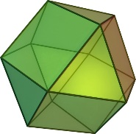 | Estimate of the probability of the cuboctahedron landing on a square face:

