Fill in the Blanks | Tree Diagrams for Dependent Events

Question | Tree Diagram | Probability
There are 6 red balls and 4 green balls in a bag. Two balls are chosen at random. Complete the tree diagram and calculate the probability of each outcome. | 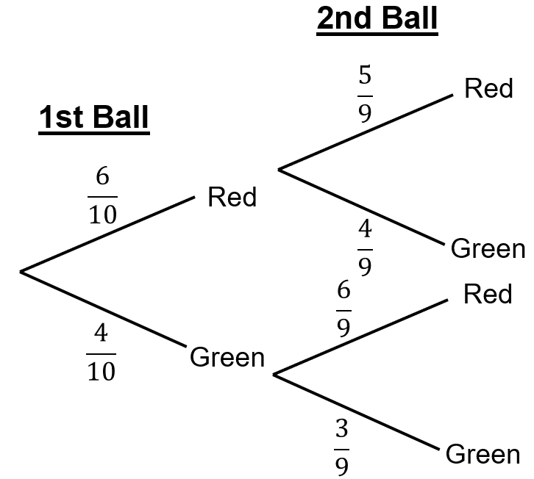 | $$P\left(RR\right)= \frac{6}{10} × \frac{5}{9} =$$ | $$\frac{30}{90}$$
 |  | $$P\left(RG\right)= \frac{6}{10} × \frac{4}{9} =$$ | $$\frac{24}{90}$$
 |  | $$P\left(GR\right)= × =$$
 |  | $$P\left(GG\right)= × =$$
There are 6 boys and 5 girls in a football team. Two team members are chosen at random. Complete the tree diagram and calculate the probability of each outcome. | 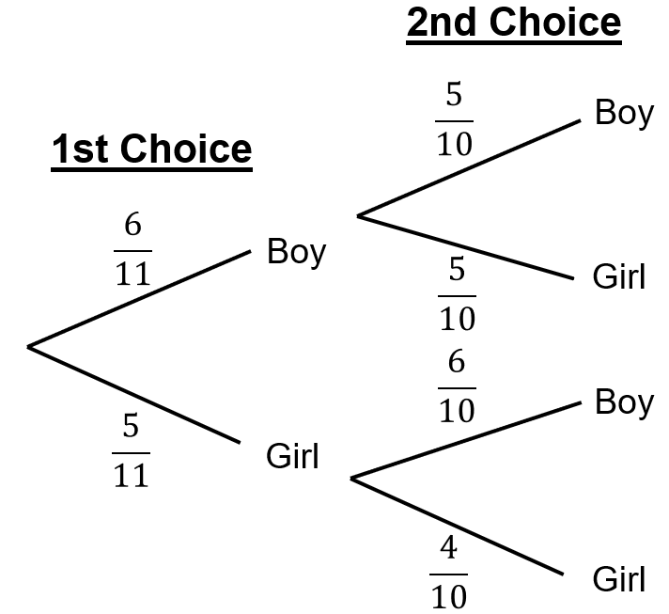 | $$P\left(BB\right)= × =$$
 |  | $$P\left(BG\right)= × =$$
 |  | $$P\left(GB\right)= × =$$
 |  | $$P\left(GG\right)= × =$$
There are 4 donuts and 3 cookies in a tin. Riaz chooses two treats at random. Complete the tree diagram and calculate the probability of each outcome. | 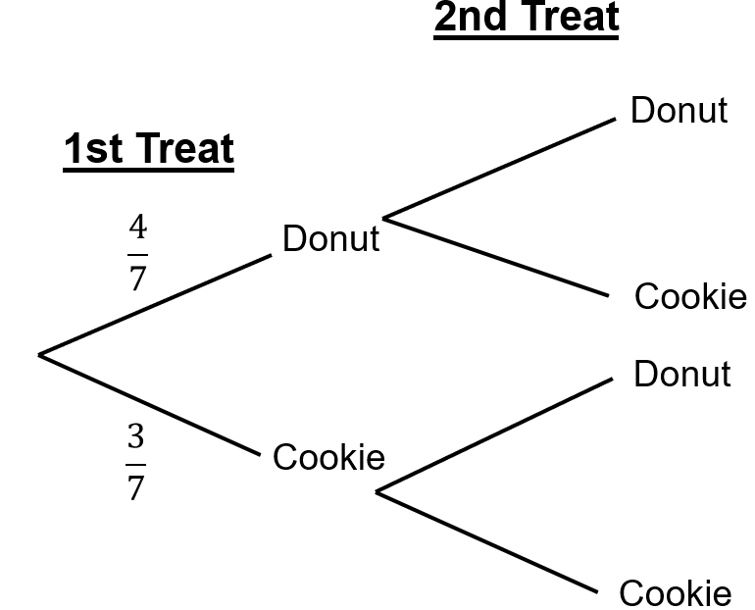 | $$P\left(DD\right)= × =$$
 |  | $$P\left(DC\right)= × =$$
 |  | $$P\left(CD\right)= × =$$
 |  | $$P\left(CC\right)= × =$$
There are 7 blue pens and 5 red pens in a pencil case. Two pens are chosen at random. Complete the tree diagram and calculate the probability of each outcome. |  | $$P\left(BB\right)=$$
 |  | $$P\left(BR\right)=$$
 |  | $$P\left(RB\right)=$$
 |  | $$P\left(RR\right)=$$

