Area of a Triangle $\left(A=\frac{1}{2}ab sin C\right)$

Find the area of the triangle.
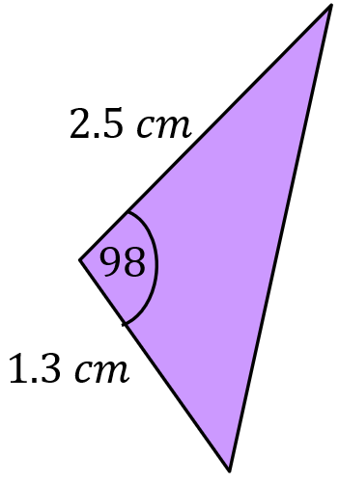
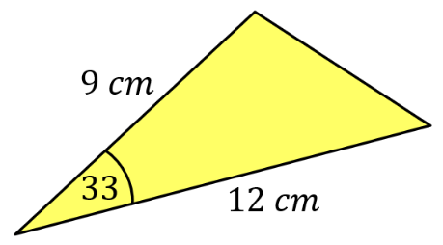
(a) (b)

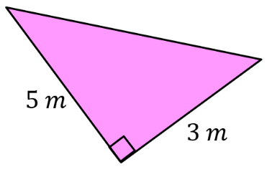
(c)

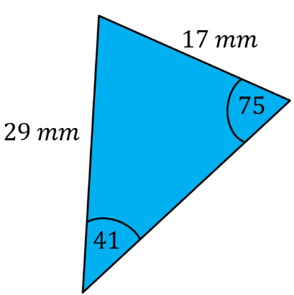
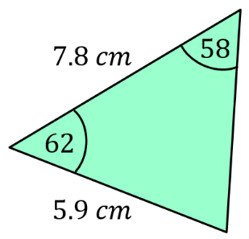
(d) (e)

Find the area of the triangle.

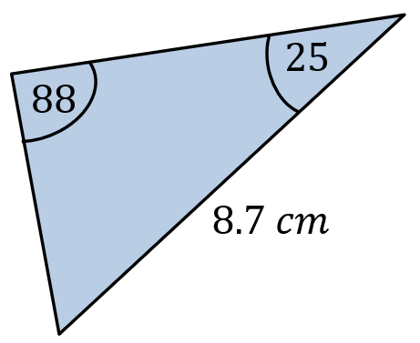
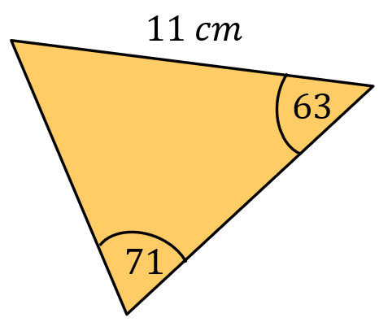
(a) (b)

Find the missing length or angle.

(a) $Area=32 {cm}^{2}$ (b) $Area=300 {mm}^{2}$
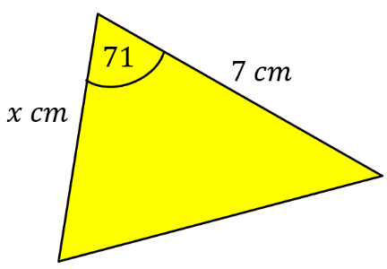
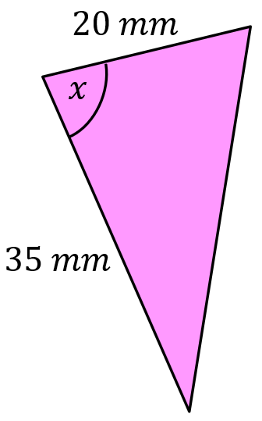

Area of a Triangle $\left(A=\frac{1}{2}ab sin C\right)$

Find the area of the triangle.
(a) (b)

(c)

(d) (e)

Find the area of the triangle.

(a) (b)

Find the missing length or angle.

(a) $Area=32 {cm}^{2}$ (b) $Area=300 {mm}^{2}$

