Transformations Revision
(a) | (b) | (c)
Translate the triangle by $\left(\begin{matrix}3 \\ -4\end{matrix}\right)$  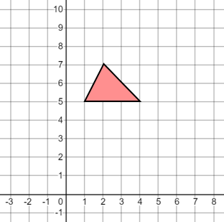 | Rotate the shape $90°$anti-clockwise about the point $(2, 2)$  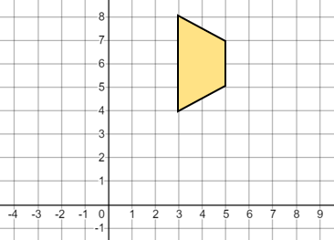 | Enlarge the shape by a scale factor $\frac{1}{2}$ with centre $(-2, 0)$  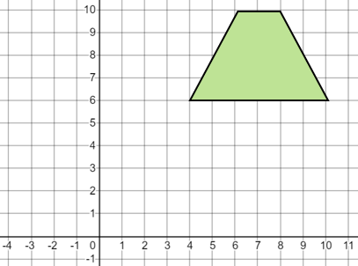
(e) | (f) | (g)
Reflect the triangle in the line $x=1$  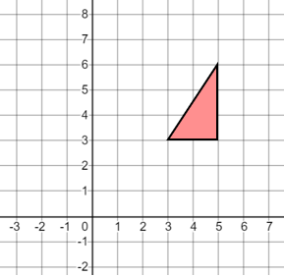 | Describe fully the single transformation that maps:  (a) triangle A onto triangle B  (b) triangle A onto triangle C  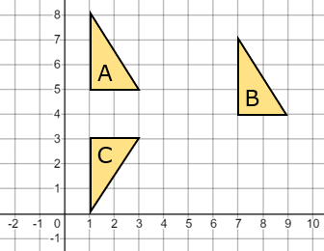 | Describe fully the single transformation that maps:  (a) triangle A onto triangle B  (b) triangle A onto triangle C  