Algebra Revision |  |  |  | 5
(a) | (b) | (c) | (d)
(i) Plot the graph of  $y=x^{3}-3x+3$  where $-2≤x≤2$  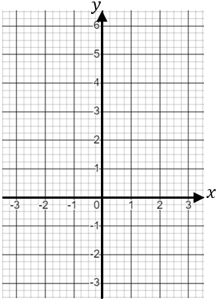  (ii) By plotting a straight line on the graph, find approximate solutions to the equation  $$x^{3}-3x+3=0.5x+2$$ | Solve $3x^{2}-5x-1=0$  giving your answers to 3 significant figures | Find the equation of the line that is perpendicular to  $y=-3x+1$ and passes through the point $(4, -2)$ | $y$ is directly proportional to the cube of $x$. When $x=5$, $y=25$.  (i) Find an equation for $y$ in terms of $x$.  (ii) Find the value of $x$ when $y=12.8$
 | (e) | (g) | (h)
 | Find the gradient of the line segment joining $(1, -5)$ and  $(-1, 2)$ | Write ${2x}^{2}-8x-5$ in the form $a{(x-b)}^{2}+c$ | Use the graph to find an estimate of the gradient at the point where $x=5$  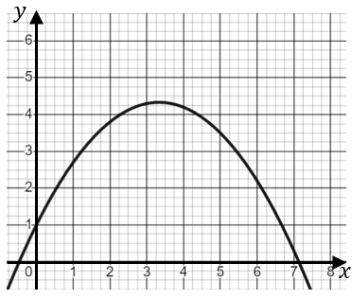
 | (f)
 | Simplify $\frac{5}{2x}+\frac{x+1}{x}-\frac{3}{5x}$

