Similar Shapes Revision
(a) | (b) | (c)
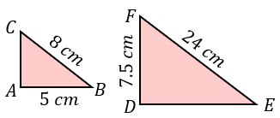  Triangles ABC and DEF are similar. Calculate the lengths of DE and AC. | 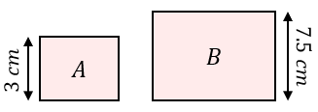  Rectangles A and B are mathematically similar. The area of A is $40 {cm}^{2}$. Work out the area of rectangle B. | 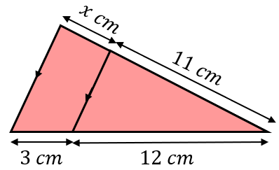  Find the missing length $x$.
(d) | (e) | (f)
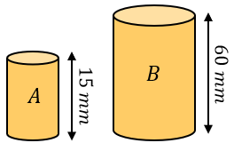  Cylinders A and B are similar. The volume of cylinder B is $2080 {cm}^{3}$. Find the volume of cylinder A. | 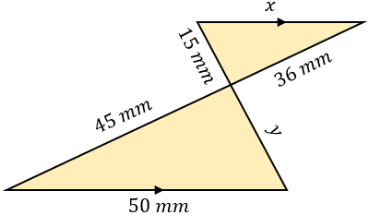  Find the missing  lengths $x$ and $y$. | 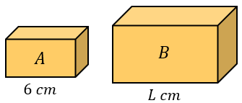  Cuboids A and B are similar. A has a volume of $28 {cm}^{3}$and B has a volume of $437.5 {cm}^{3}$. Find the length $L$.
(g) | (h) | (i)
Cones A and B are mathematically similar. Cone A has a volume of $857.5 {cm}^{3}$ and a surface area of $73.5 {cm}^{2}$. Cone B has a volume of $160 {cm}^{3}$. Find its surface area. | 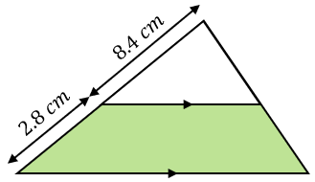  The area of the white triangle is $18 {cm}^{2}$. Find the area of the shaded region. | 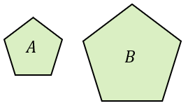  Pentagons A and B are similar. The scale factor of their lengths is $x$. The area of A is $12 {cm}^{2}$. If the area of B is $(16x+3) {cm}^{2}$, find the value of $x$.

