Angle Notation in Circle Theorems

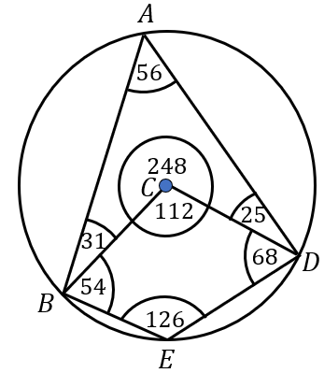

Write down the size of the following angles:
(a) $ABC$ (b) $BED$
(c) $BAD$ (d) $EDC$
(e) $CDA$ (f) $EBA$
(g) the obtuse angle $DCB$
(h) the reflex angle $DCB$

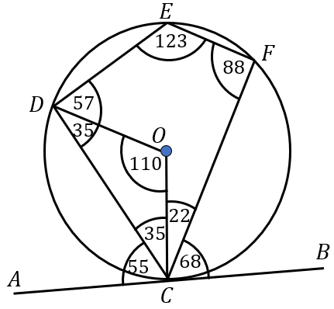
Write down the size of the following angles:
(a) $DEF$ (b) $CFE$
(c) $OCD$ (d) $DCA$
(e) $BCF$ (f) $OCA$
(g) $DCB$ (h) $EDC$

Angle Notation in Circle Theorems

Write down the size of the following angles:
(a) $ABC$ (b) $BED$
(c) $BAD$ (d) $EDC$
(e) $CDA$ (f) $EBA$
(g) the obtuse angle $DCB$
(h) the reflex angle $DCB$

Write down the size of the following angles:
(a) $DEF$ (b) $CFE$
(c) $OCD$ (d) $DCA$
(e) $BCF$ (f) $OCA$
(g) $DCB$ (h) $EDC$

