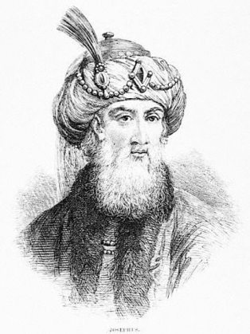
The Josephus Problem
In 67AD, Josephus Flavius, commander of Galilee, and 40 of his soldiers, were besieged in a cave by a Roman army. Rather than be captured, the 41 soldiers decided to end their own lives…
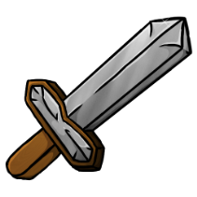
They formed a circle, numbering themselves from 1 to 41. Number 1 took the sword and killed number 2, then passed the sword to number 3, who killed number 4. They continued this until only one person was remaining...
Clever Josephus worked out which position he had to be in to be the last remaining soldier. Can you?

Size of group | 2 | 3 | 4 | 5 | 6 | 7 | 8 | 9 | 10 | 11 | 12 | 13
Position of last person |  |  |  |  | 5
Size of group | 14 | 15 | 16 | 17 | 18 | 19 | 20 | 21 | 22 | 23 | 24 | 25
Position of last person

The aim is to find a pattern and then a rule that gives the position of the last person for any group size. What have you found?

What position did Josephus take in order to be the last soldier standing?

