Crack the Code | Solving Quadratics, Cubics and Quartics

NO CALCULATORS ALLOWED
A | The roots of the equation  $z^{2}+4z+5=0$are   | B | The roots of the equation  $z^{2}-6z+13=0$are
C | The roots of the equation  $4z^{2}-16z+25=0$are | D | The roots of the equation  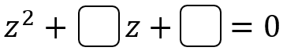  are $-5+3i$ and $-5-3i$
E | The roots of the equation  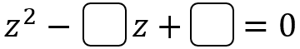  are $4+2i$ and $4-2i$ | F | The roots of the equation  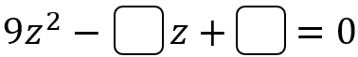  are $\frac{2}{3}+\frac{4}{3}i$ and $\frac{2}{3}-\frac{4}{3}i$
G | The roots of the equation  $$z^{3}-9z^{2}+28z-30=0$$  are $3$, | H | The roots of the equation  $$z^{3}+8z^{2}+29z+52=0$$  are $-4$,
I | The roots of the equation  $$z^{3}-18z^{2}+117z-270=0$$  are $6+3i,$   | J | The roots of the equation  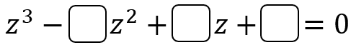  are $-2,$ $7-2i$and  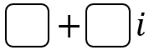
K | The roots of the equation  $$z^{4}-2z^{3}-15z^{2}+76z-120=0$$  are $-5, 3,$ | L | The roots of the equation  $$z^{4}-16z^{3}+75z^{2}-58z-150=0$$  are $7-i$,  
To get the three-digit code, add together all the numbers in the boxes.

