Shading Three Set Venn Diagrams
(a) | (b)
Shade the region corresponding to  $A∩B$  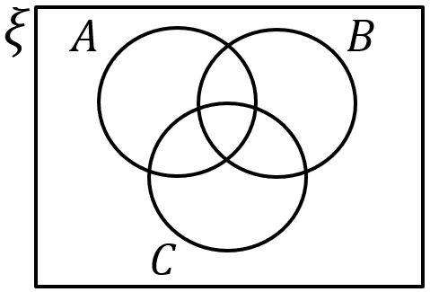 | Shade the region corresponding to  $${\left(B∪C\right)}^{'}$$
(c) | (d)
Shade the region corresponding to  $$A'∩B$$ | Shade the region corresponding to  $$(A∩B∩C)'$$
(e) | (f)
Shade the region corresponding to  $$(A∪B∪C)'$$ | Shade the region corresponding to  $$(A∩C)∩B'$$
(g) | (h)
Shade the region corresponding to  $$A'∩(B∪C)$$ | Shade the region corresponding to  $$(B∪C)∪A'$$

