Pythagoras in 3D

Find the length of the diagonal to 1dp.
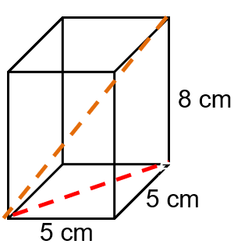
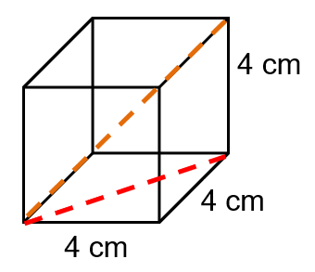
(a) (b)

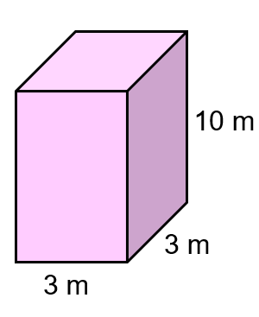
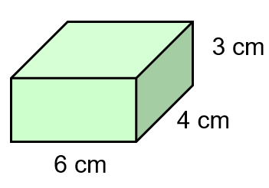
(c) (d)

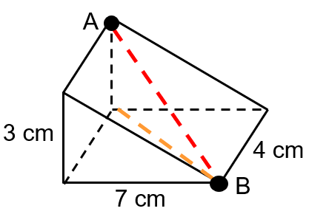
Find the distance AB to 1dp.
(a)

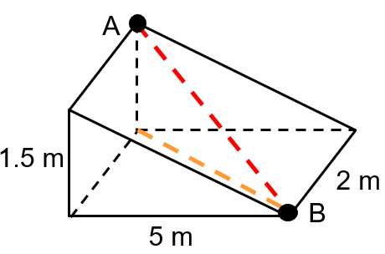
(b)

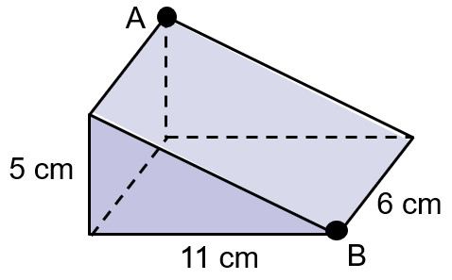
(c)

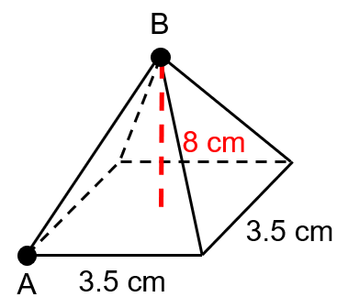
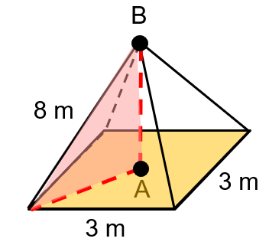
(d) (e)

Pythagoras in 3D

Find the length of the diagonal to 1dp.
(a) (b)

(c) (d)

Find the distance AB to 1dp.
(a)

(b)

(c)

(d) (e)

