Maclaurin Series
Find the terms up to and including $x^{4}$ of the Maclaurin series for each of these functions.
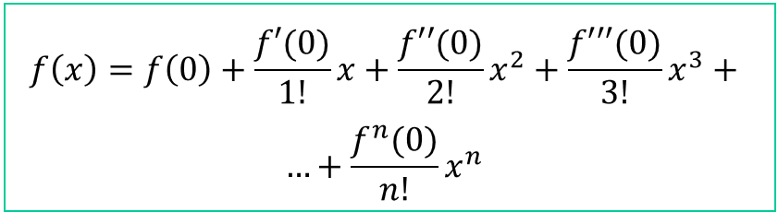
(a) | (b)
$$f\left(x\right)=\cos{(2x)}$$  $$f(x)$$ $$\cos{(2x)}$$ $$f(0)$$ $$1$$  $$f'(x)$$ $$-2\sin{(2x)}$$ $$f'(0)$$ $$0$$  $$f''(x)$$ $$-4 cos{(2x)}$$ $$f''(0)$$  $$f'''(x)$$ $$f'''(0)$$  $$f^{4}(x)$$ $$f^{4}(0)$$ | $$f\left(x\right)=e^{-5x}$$  $$f(x)$$ $$f(0)$$  $$f'(x)$$ $$f'(0)$$  $$f''(x)$$ $$f''(0)$$  $$f'''(x)$$ $$f'''(0)$$  $$f^{4}(x)$$ $$f^{4}(0)$$
(c) | (d)
$$f\left(x\right)=\sin\left(-\frac{1}{2}x\right)$$  $$f(x)$$ $$f(0)$$  $$f'(x)$$ $$f'(0)$$  $$f''(x)$$ $$f''(0)$$  $$f'''(x)$$ $$f'''(0)$$  $$f^{4}(x)$$ $$f^{4}(0)$$ | $$f\left(x\right)=\ln{(1+4x)}$$  $$f(x)$$ $$f(0)$$  $$f'(x)$$ $$f'(0)$$  $$f''(x)$$ $$f''(0)$$  $$f'''(x)$$ $$f'''(0)$$  $$f^{4}(x)$$ $$f^{4}(0)$$

