Fill in the Blanks | Sample Spaces

Sample Space |  | Probability Questions
A fair four-sided spinner is numbered 1 to 4. The spinner is spun twice, and the two scores added together. | 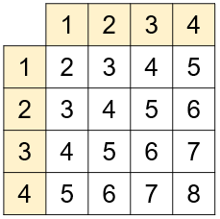 | Find the probability that the total score is 7.
 |  | Find the probability that the total score is greater than 4.
 |  | Find the probability that the total score is a multiple of 3.
A fair four-sided dice is numbered 2, 3, 4 and 5. The spinner is spun twice, and the two scores added together. | 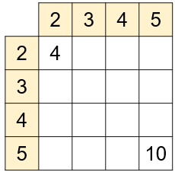 | Find the probability that the total score is 8.
 |  | Find the probability that the total score is less than 7.
 |  | Find the probability that the total score is a multiple of 4.
A fair four-sided dice is numbered 1, 2, 3 and 4. The spinner is spun twice, and the two scores multiplied together. | 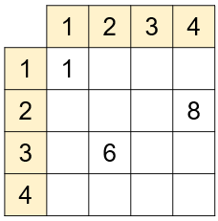 | Find the probability that the total score is even.
 |  | Find the probability that the total score is greater than 6.
 |  | Find the probability that the total score is prime.
A fair four-sided spinner is numbered 2, 3, 5 and 7. The spinner is spun and the difference between the two scores recorded. | 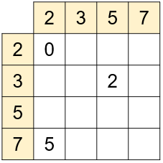 | Find the probability that the difference is zero.
 |  | Find the probability that the difference is odd.
 |  | Find the probability that the difference is two or more.
Two fair four-sided spinners are spun, and the scores added together. The first spinner is numbered 1, 2, 3 and 4 and the second spinner is numbered 3, 5, 7  and 9. | 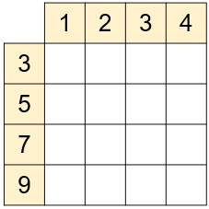 | Find the probability that the total score is 10.
 |  |  | $$\frac{5}{16}$$
 |  |  | $$\frac{3}{8}$$

