More Solving Equations with Unknowns on Both Sides

Solve these equations.
(a) $3x+1=2x+9$
(b) $4x+1=2x+9$
(c) $1+4x=x+10$
(d) $4x-3=x+15$
(e) $4x+7=2x-1$
(f) $6x+5=10+4x$

Solve these equations.
(a) $2x+1=7x+16$
(b) $3x-2=9x+10$
(c) $x-8=4x+7$
(d) $5x+14=8x-1$
(e) $9+4x=6x-2$
(f) $x-7=5x-5$

Solve these equations.
(a) $6+2x=11-3x$
(b) $7x-3=12-3x$
(c) $1-4x=5+4x$
(d) $11-x=7-2x$
(e) $6.5-5x=2.5x-4$
(f) $-3x-7=11-8x$

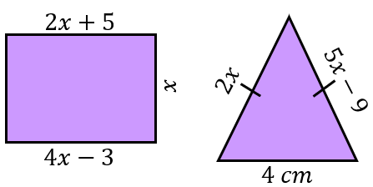
(a) The rectangle shown has opposite sides of length $(2x+5) cm$ and
$(4x-3) cm$. Find the value of$x$ and hence its area.

(b) Given that the triangle shown is isosceles, find the value of $x$and hence its perimeter.
More Solving Equations with Unknowns on Both Sides

Solve these equations.
(a) $3x+1=2x+9$
(b) $4x+1=2x+9$
(c) $1+4x=x+10$
(d) $4x-3=x+15$
(e) $4x+7=2x-1$
(f) $6x+5=10+4x$

Solve these equations.
(a) $2x+1=7x+16$
(b) $3x-2=9x+10$
(c) $x-8=4x+7$
(d) $5x+14=8x-1$
(e) $9+4x=6x-2$
(f) $x-7=5x-5$

Solve these equations.
(a) $6+2x=11-3x$
(b) $7x-3=12-3x$
(c) $1-4x=5+4x$
(d) $11-x=7-2x$
(e) $6.5-5x=2.5x-4$
(f) $-3x-7=11-8x$

(a) The rectangle shown has opposite sides of length $(2x+5) cm$ and
$(4x-3) cm$. Find the value of$x$ and hence its area.

(b) Given that the triangle shown is isosceles, find the value of $x$and hence its perimeter.

