Match-Up | Reading Bar Charts

Match two correct statements to each bar chart showing students’ favourite colours.
1 | 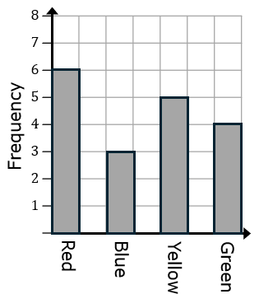 |  | 2 | 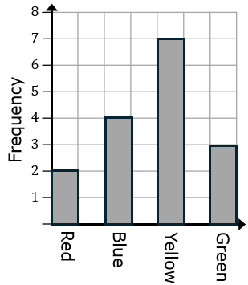 |  | 3 | 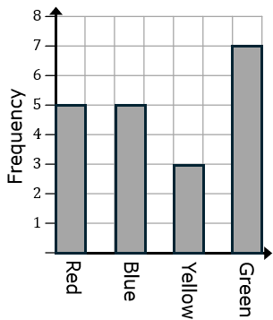
4 | 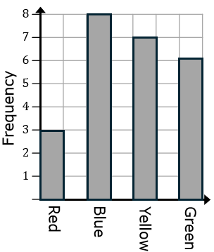 |  | 5 | 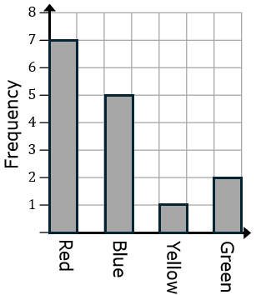 |  | 6 | 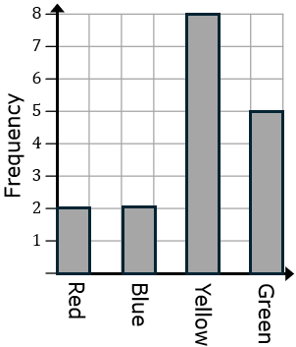
A | Three more students said yellow was their favourite than said blue. |  | B | A total of $15$ students were surveyed. |  | C | Seven students said red or green was their favourite colour.
D | Twice as many students preferred green than red as their favourite colour. |  | E | Twelve students did not choose red as their favourite colour. |  | F | A total of $24$ students were surveyed.
G | Half of students said yellow or green was their favourite colour. |  | H | Three more students said blue was their favourite than said green. |  | I | The ratio of students who preferred yellow to red was $4:1$
J | The most popular colour chosen by students was green. |  | K | One third of students said red was their favourite colour. |  | L | $12.5\%$ of students said their favourite colour was red.

1 |  | 2 |  | 3 |  | 4 |  | 5 |  | 6

