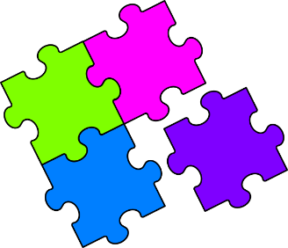
Match-Up
Equivalent Mass, Volume and Capacity

1 | $$5.2 kg$$ |  | 6 | $$52 tonnes$$ |  | 11 | $$380 kg$$ |  | 16 | $$17.5 {cm}^{3}$$
2 | $$52 ml$$ |  | 7 | $$5200 kg$$ |  | 12 | $$3.8 tonnes$$ |  | 17 | $$17.5 kg$$
3 | $$5.2 litres$$ |  | 8 | $$3.8 {cm}^{3}$$ |  | 13 | $$380 ml$$ |  | 18 | $$1.75 litres$$
4 | $$520 g$$ |  | 9 | $$38 kg$$ |  | 14 | $$38 ml$$ |  | 19 | $$1.75 tonnes$$
5 | $$520 {cm}^{3}$$ |  | 10 | $$3.8 litres$$ |  | 15 | $$175 ml$$ |  | 20 | $$175 g$$
A | $$52000 kg$$ |  | F | $$0.52 kg$$ |  | K | $$0.175 kg$$ |  | Q | $$0.38 tonnes$$
B | $$38000 g$$ |  | G | $$3.8 ml$$ |  | L | $$5200 g$$ |  | R | $$1750 {cm}^{3}$$
C | $$0.175 litres$$ |  | H | $$17500 g$$ |  | M | $$3800 {cm}^{3}$$ |  | S | $$5.2 tonnes$$
D | $$52 {cm}^{3}$$ |  | I | $$3800 kg$$ |  | N | $$1750 kg$$ |  | T | $$520 ml$$
E | $$0.38 litres$$ |  | J | $$5200 ml$$ |  | P | $$38 {cm}^{3}$$ |  | U | $$17.5 ml$$

1 | 2 | 3 | 4 | 5 | 6 | 7 | 8 | 9 | 10
11 | 12 | 13 | 14 | 15 | 16 | 17 | 18 | 19 | 20

