Nth Term of Quadratic Sequences

Find the nth term of these sequences:
(a) $8, 11, 16, 23,…$
(b) $-4, -1, 4, 11,…$
(c) $6, 12, 22, 36,…$
(d) $-1, 5, 15, 29,..$
(e) $4, 13, 28, 49,…$
(f) $2, 14, 34, 62,…$

Find the nth term of these sequences:
(a) $3, 7, 13, 21,…$
(b) $2, 7, 14, 23,…$
(c) $9, 18, 31, 48,…$
(d) $1, 5, 13, 25,…$
(e) $7, 23, 49, 85,…$
(f) $7, 15, 29, 49,…$

Find the nth term of these sequences:
(a) $10.5, 12, 14.5, 18,…$
(b) $5.5, 9, 13.5, 19,…$
(c) $1.5, 5, 11.5, 21,…$
(d) $3.5, 10, 19.5, 32,…$
(e) $19, 16, 11, 4, -5,…$
(f) $5, 6, 5, 2, -3,…$

The number of squares in each of these shapes form a quadratic sequence. Find the nth term for this sequence.
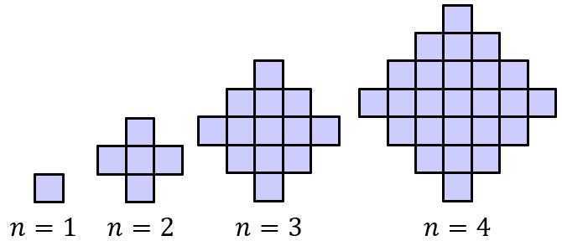

Nth Term of Quadratic Sequences

Find the nth term of these sequences:
(a) $8, 11, 16, 23,…$
(b) $-4, -1, 4, 11,…$
(c) $6, 12, 22, 36,…$
(d) $-1, 5, 15, 29,..$
(e) $4, 13, 28, 49,…$
(f) $2, 14, 34, 62,…$

Find the nth term of these sequences:
(a) $3, 7, 13, 21,…$
(b) $2, 7, 14, 23,…$
(c) $9, 18, 31, 48,…$
(d) $1, 5, 13, 25,…$
(e) $7, 23, 49, 85,…$
(f) $7, 15, 29, 49,…$

Find the nth term of these sequences:
(a) $10.5, 12, 14.5, 18,…$
(b) $5.5, 9, 13.5, 19,…$
(c) $1.5, 5, 11.5, 21,…$
(d) $3.5, 10, 19.5, 32,…$
(e) $19, 16, 11, 4, -5,…$
(f) $5, 6, 5, 2, -3,…$

The number of squares in each of these shapes form a quadratic sequence. Find the nth term for this sequence.

