Solving Simultaneous Equations Graphically
(a) | (b)
Plot the graphs of  $x+y=5$ and $x+3y=9$  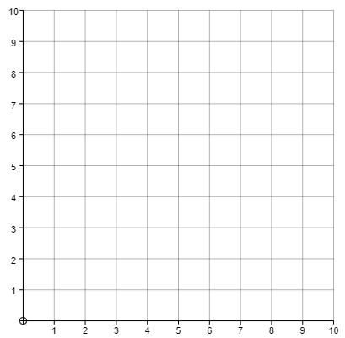  Find the solution to the simultaneous equations $x+y=5$ and $x+3y=9$ | Plot the graphs of  $x+y=7$ and $5x+2y=20$  Find the solution to the simultaneous equations $x+y=7$ and $5x+2y=20$
(c) | (d)
Plot the graphs of  $y=x+1$ and $x+y=9$  Find the solution to the simultaneous equations $y=x+1$ and $x+y=9$ | Plot the graphs of  $y=2x$ and $2x+y=12$  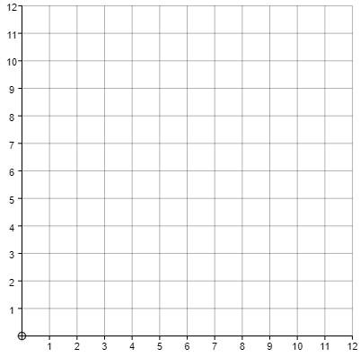  Find the solution to the simultaneous equations $y=2x$ and $2x+y=12$
(e)
Plot the graphs of $x+y=8$, $y=x$, $y=\frac{1}{2}x+5$ and $x+y=11$

Use the graphs to find the solutions of the simultaneous equations:
(i) $x+y=8$ and $y=x$

(ii) $x+y=8$ and $y=\frac{1}{2}x+5$

(iii) $y=x$ and $x+y=11$

