Statistics and Probability Revision |  |  |  | 2
(a) |  | (b) | (c)
The bar chart shows the maximum July temperature, in $°C$, in each of four cities across the world. |  | Here is a list of Brooke’s last seven scores in her spelling tests.  $$9 7 4 7 8 5 7$$  (i) Write down the mode of these scores.  (ii) Find the range of Brooke’s spelling test scores. | The two-way table shows the favourite science of 90 students surveyed in Year 7 and Year 8. Complete the two-way table.  Y7 Y8 Total  Physics 17 25  Biology 20  Chemistry 13  Total 43 90
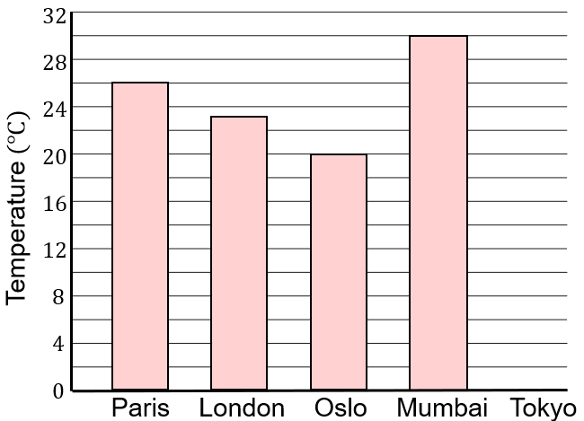
(i) Write down the maximum July temperature for London.

(ii) The maximum July temperature for Tokyo is $19°C$. Draw a bar on the chart to show this information.

(d) |  | (e) | (f)
A fair four-sided dice is thrown twice, and the scores added together. |  | Here are the number of books read by each of eight students across a one year period.  $$11 5 6 5 12 9 10 10$$  (i) Find the median number of books read.  (ii) Calculate the mean number of books read. | $$ξ=\left\{1, 2, 3, 4, 5, 6, 7, 8, 9, 10\right\}$$  $$A=\{odd numbers\}$$  $$B=\{prime numbers\}$$  (i) List all the members of the set $A∩B$  (ii) List all the members of the set $A∪B$
(i) Complete the table to show all the possible scores.  First Throw  1 2 3 4  Second Throw 1 4  2  3 5  4 | (ii) Find the probability that when the dice is thrown twice the total score is 4.  (ii) Find the probability that when the dice is thrown the total score is an odd number.

