Using Algebra in Shapes
(a) | (b) | (c) | (d)
The perimeter of the square is $20 cm$. Find the value of $x$.  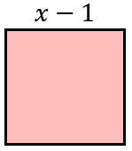 | The perimeter of the rectangle is $20 cm$. Find the value of $x$.  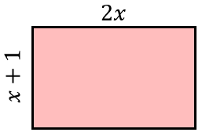 | The perimeter of the triangle is $29 cm$. Find the value of $x$.  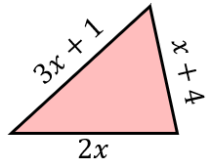 | The perimeter of the rectangle is $34 cm$. Find the value of $x$.  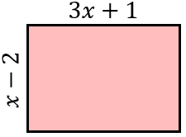
(e) | (f) | (g) | (h)
The area of the rectangle is $36 {cm}^{2}$. Find the value of $x$.  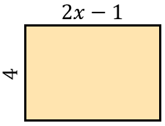 | The area of the triangle is $50 {cm}^{2}$. Find the value of $x$.  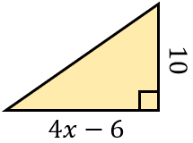 | The perimeter of the rectangle is $28 cm$. Find its area.  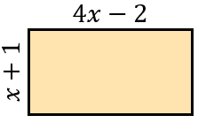 | The perimeter of the triangle is $24 cm$. Find its area.  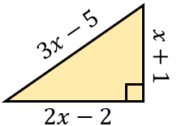
(i) | (j) | (k) | (l)
Find the perimeter of this rectangle.  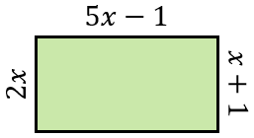 | Find the perimeter of this triangle.  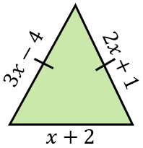 | The perimeter of the triangle is equal to the perimeter of the rectangle. Find the value of $x$.  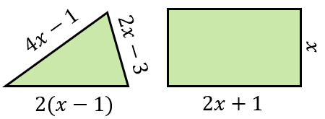 | The area of the rectangle is twice the area of the triangle. Work out the value of $x$.  