Crack the Code
Volume and Surface Area of Prisms
A | 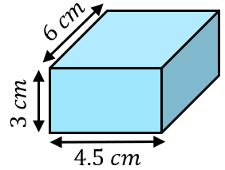  Find the volume. | B | 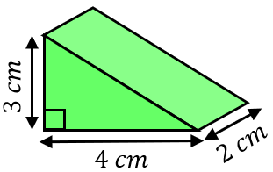  Find the volume.
C | Find the surface area of the cube.  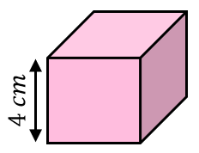 | D | 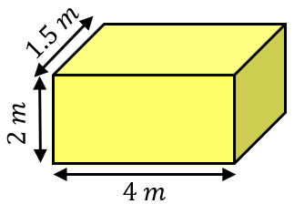  Find the surface area.
E | 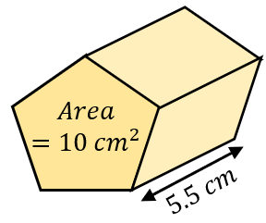  Find the volume. | F | 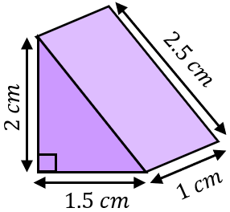  Find the surface area.
G | 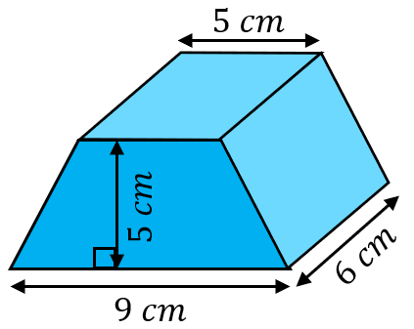  Find the volume. | H | 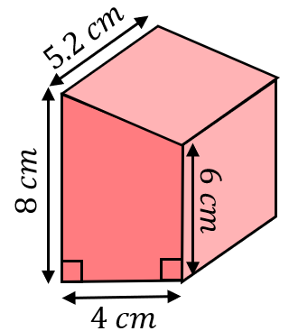  Find the volume.
I | 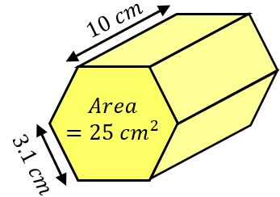  Find the surface area. The cross section is a regular  hexagon. | J | 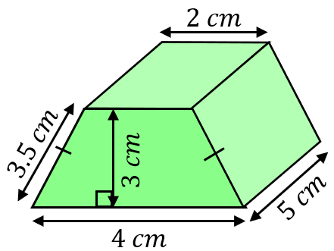  Find the surface area.
K | 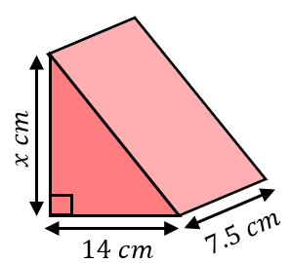  The volume is $840 {cm}^{3}$. Find the value of $x$. | L | 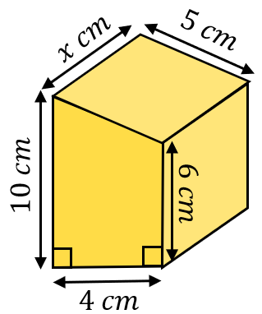  The surface area is $239 {cm}^{2}$. Find the value of $x$.
To get the three-digit code, add all your answers together and round to the nearest integer.

