Pythagoras’ Theorem Revision
(a) | (b) |  | (c) |  | (d)
Find the value of $x$ to 1 decimal place.  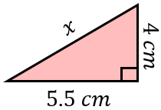 | Find the value of $y$ to 3 significant figures.  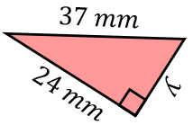 |  | A triangle has sides of lengths $10.5 cm$, $12 cm$ and $16.5 cm$. Is the triangle right-angled? Explain your answer. |  | Find the perimeter of the triangle to 3 significant figures.  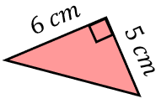
(e) | (f) |  | (g) |  | (h)
Find the distance between the coordinates $(1, 6)$ and $(3, 2)$, giving an exact answer. | Find the value of $x$ to 3 significant figures.  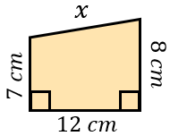 |  | Find the area of the isosceles triangle to 1 decimal place.  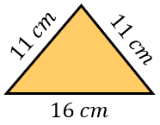 |  | From point A, a boat sails 80 km east. It then turns and sails 110 km south to point B. Find the distance AB to the nearest km.
(i) |  | (j) |  | (k)
Find the value of $y$ to 3 significant figures.  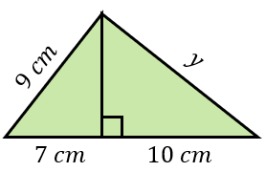 |  | The area of the isosceles triangle is $40 {cm}^{2}$. Find the perimeter of the triangle, to 1 decimal place.  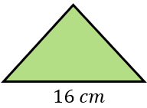 |  | Find the length of the line AB, giving your answer to 3 significant figures.  