Numerical Methods Revision
(a) | (b) | (c)
$$x_{n+1}=\frac{e^{x_{n}}}{x_{n}+3}$$  Using $x_{1}=1$ find the values of $x_{2}, x_{3}$ and $x_{4}$ to 4 decimal places. | $$f\left(x\right)=\ln\left(2x\right)-\frac{3}{x}$$  The equation $f\left(x\right)=0$ has a single root $α.$  Show that $α$ lies in the interval $[2, 2.1]$. | $$f\left(x\right)=x^{3}-x-2\sin{x}$$  Show that the equation $f\left(x\right)=0$ can be written as the iterative formula  $$x_{n+1}=\sqrt{1+\frac{2\sin{x_{n}}}{x_{n}}}$$
(d) | (e) | (f)
Show that the equation $x^{3}-\sqrt{x}=3$ has the solution $x=1.623$ to 3 decimal places. | $$x_{n+1}=2+3\ln{x_{n}}$$  Using $x_{0}=6,$ find $x_{1, }x_{2}$ and $x_{3}$. Hence find the root of the equation $2+3\ln{x}-x=0$ to 3 decimal places. | The iterative formula  $$x_{n+1}=5+2\ln\left(\frac{1}{x_{n}+3}\right)$$  is used to find an approximate solution to the equation $5-x+2\ln\left(\frac{1}{x+3}\right)=0$  Given $x_{1}=1$, show using a cobweb or staircase diagram how the convergence towards the root takes place.  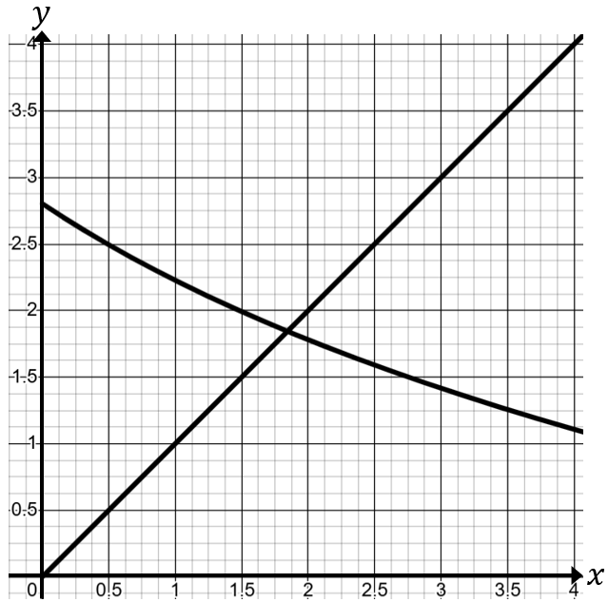
(g) | (h)
Use the Newton-Raphson method with  $x_{1}=1$to find an approximate root to the equation $5+x-e^{x}=0$ to 3 decimal places. | The height of a ball as a function of time can be modelled by the equation  $h\left(t\right)=5\sqrt{t}-\frac{1}{2}t^{3}$ $t≥0$  Taking a first approximation of $t=2 s$, use the Newton-Raphson method once to find a second approximation for the time when the ball hits the ground. Give your answer to 3 significant figures.

