Rotational Symmetry
Add the number of squares specified to get the required order of rotational symmetry.
(a) | (b) | (c)
Add one square for order 2  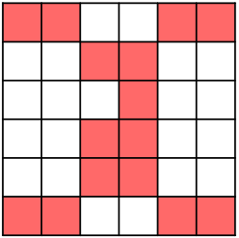 | Add two squares for order 2  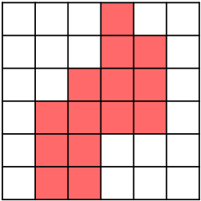 | Add 3 squares for order 2  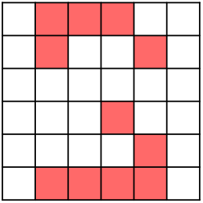
(d) | (e) | (f)
Add two squares for order 4  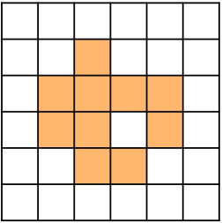 | Add 3 squares for order 4  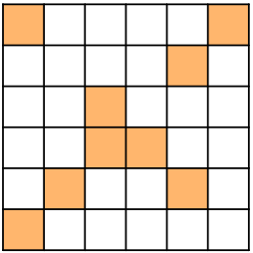 | Add two squares for order 2  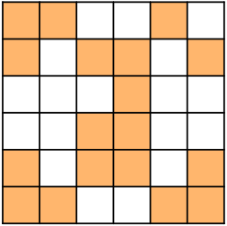
(g) | (h) | (i)
Add 4 squares for order 2  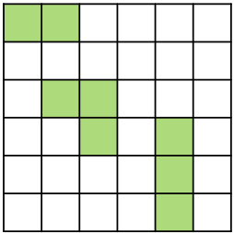 | Add two squares for order 4  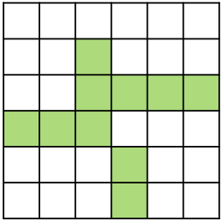 | Add 3 squares for order 4  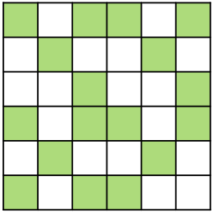
(j) | (k) | (l)
Add 4 squares for order 4  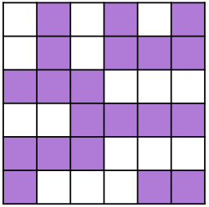 | Add 3 squares for order 2  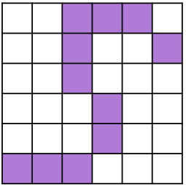 | Add 5 squares for order 4  