Area of Triangles

Find the area of the triangles on these ${cm}^{2}$ grids.
(a) (b)
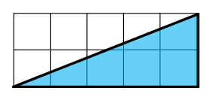
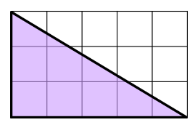

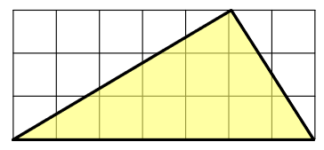
(c) (d)
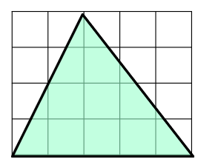

Find the area of each of these triangles.
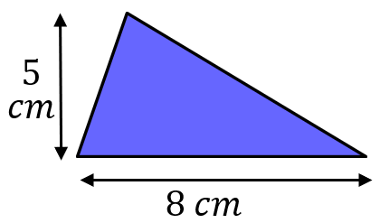
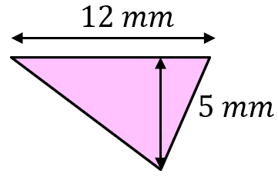
(a) (b)

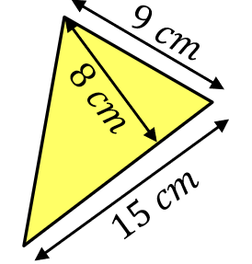
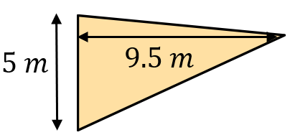
(c) (d)

Given the area, find the missing base or height.
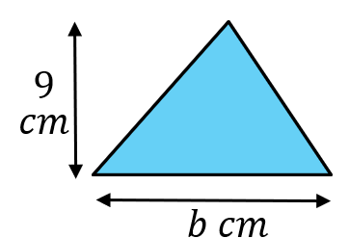
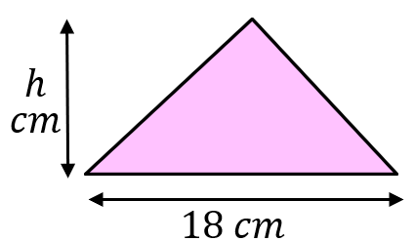
(a) $Area=72 {cm}^{2}$ (b) $Area=22.5 {mm}^{2}$

A triangle has an area of $32 {cm}^{2}$. Find as many possible pairs of bases and heights as you can.
Area of Triangles

Find the area of the triangles on these ${cm}^{2}$ grids.
(a) (b)

(c) (d)

Find the area of each of these triangles.
(a) (b)

(c) (d)

Given the area, find the missing base or height.
(a) $Area=72 {cm}^{2}$ (b) $Area=22.5 {mm}^{2}$

A triangle has an area of $32 {cm}^{2}$. Find as many possible pairs of bases and heights as you can.

