Sine and Cosine Rules Revision
(a) | (b) | (c) | (d)
Find the area of the triangle.  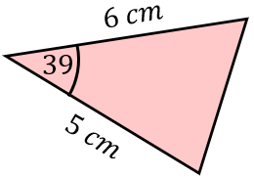 | 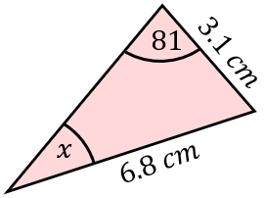  Find $x$ to 1 decimal place. | 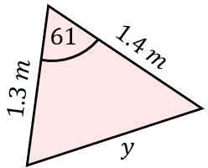  Find $y$ to 2 decimal places. | Find $x$ to 3 significant figures.  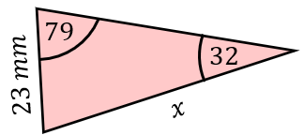
(e) | (f) | (g) | (h)
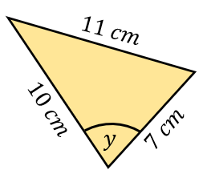  Find $y$ to 1 decimal place. | Find $x$ to 1 decimal place.  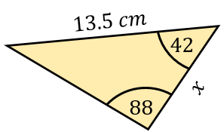 | 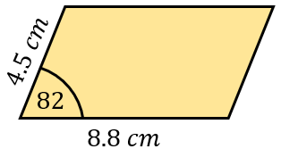  Find the area of the parallelogram. | 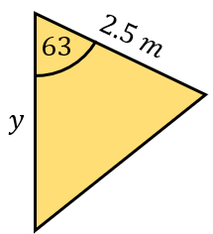  The area of the triangle is 4.6 m². Find $y$ to 1 decimal place.
(i) | (j) | (k) | (l)
Find $y$ to 3 significant figures.  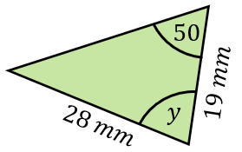 | 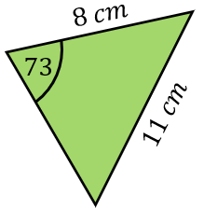  Find the area of the triangle. | 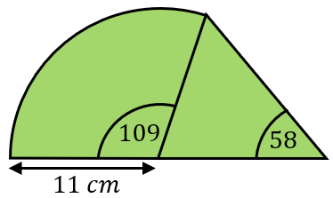  Find the area of the compound shape. | 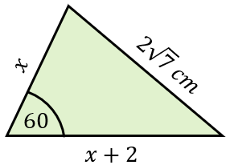  Find the value of $x$.

