Origami Bat
To make this bat you will need a 15 cm square of origami paper.
Step 1 – Fold the square in half horizontally. | Step 2 – Open the paper back up and rotate through 90º. | Step 3 –Fold the square in half horizontally again.
Step 4 – Open back up, then fold the bottom edge to meet the middle fold.  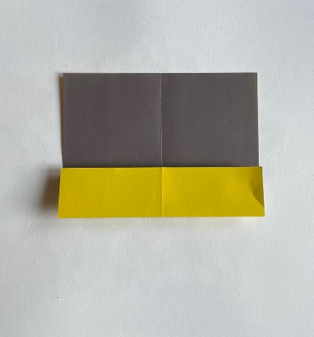 | Step 5 – Repeat by folding the top edge down to meet the middle fold.  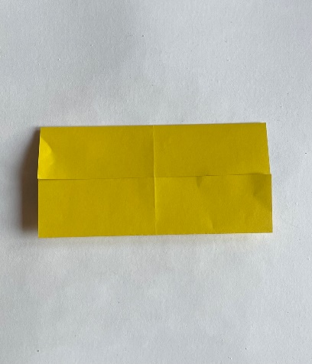 | Step 6 – Fold the bottom edge up to the bottom horizontal fold. Open up.
Step 7 – Flip over and make a diagonal fold by bringing the bottom right corner to meet the top left corner.  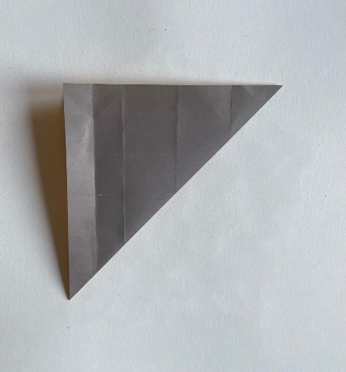 | Step 8 – Open back up and fold the other diagonal, bottom left to top right.  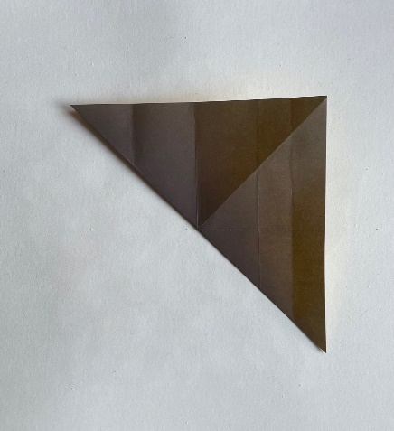 | Step 9 – Open back up and turn over.  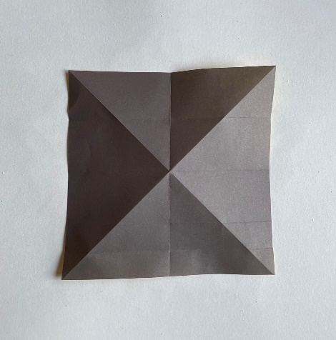
Step 10 – Push the left and right sides in at the centre and flatten to form a triangle.  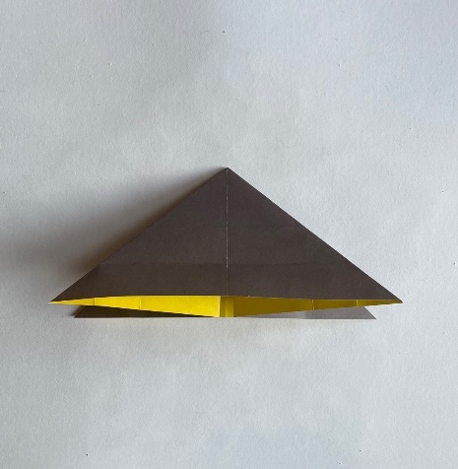 | Step 11 – Turn upside down, so the side facing has only one horizontal fold.  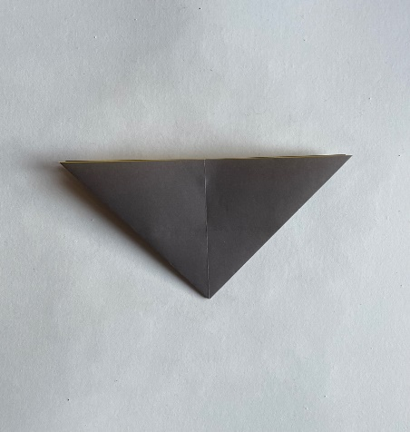 | Step 12 – At the front only, pull the top middle down to the bottom point.  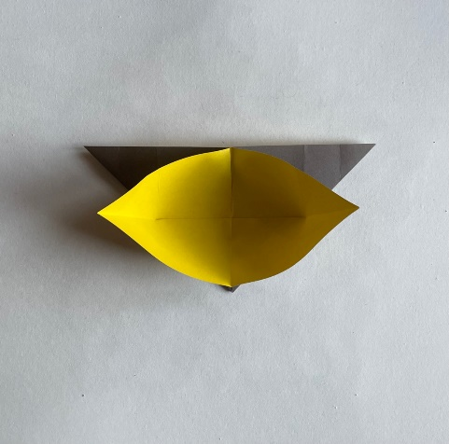
Step 13 – Take the right-hand point and bring it to the top middle. Flatten down.  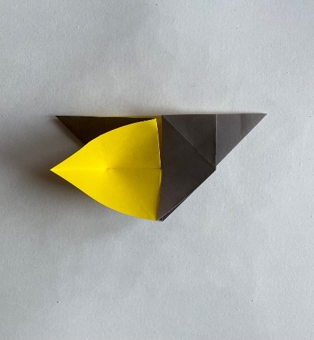 | Step 14 – Repeat on the left-hand side to match.  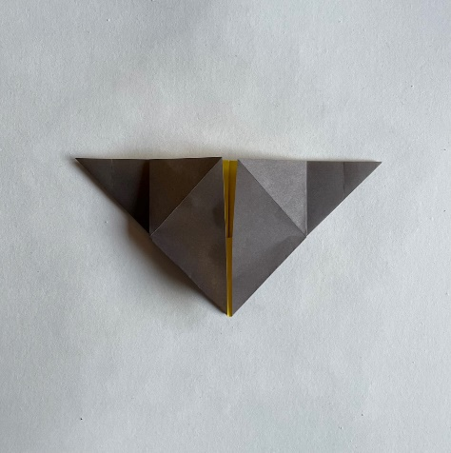 | Step 15 – Take the bottom point at the front only and fold up to meet the centre of the top edge.  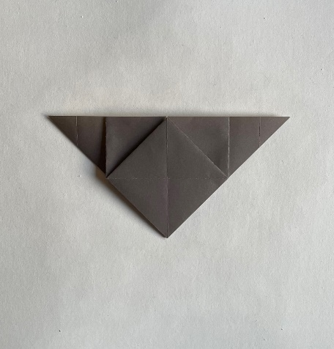
Step 16 – Turn the front piece on the left across to the right, like turning a page of a book.  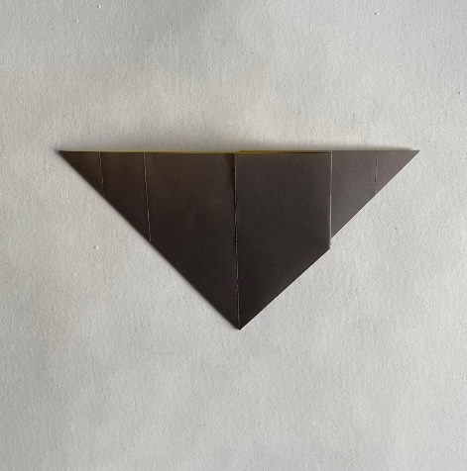 | Step 17 – Fold this page in half vertically, so the left-hand edge meets the centre fold.  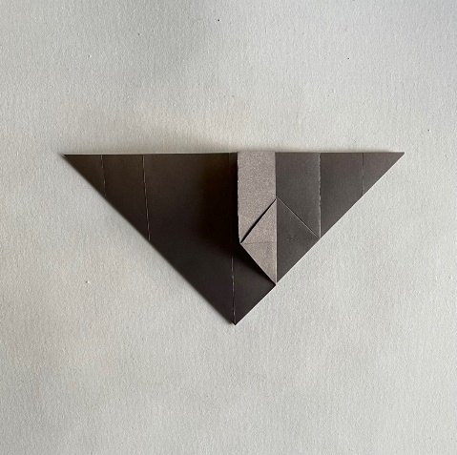 | Step 18 – Now make a fold on this narrow ‘page’, from the bottom point to the middle horizontal fold.  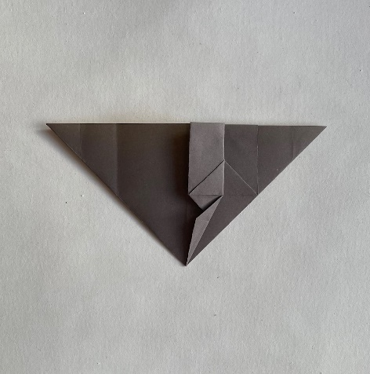
Step 19 – Turn this narrower ‘page’ back to the left.  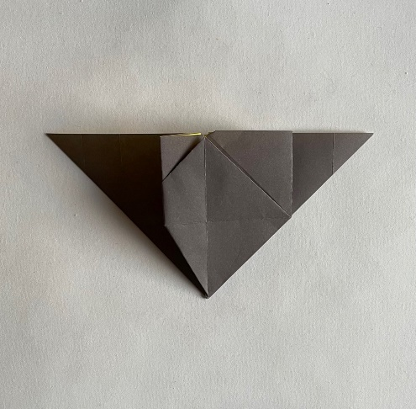 | Step 20 – Now repeat by turning the right-hand ‘page’ across to the left and folding this in half vertically.  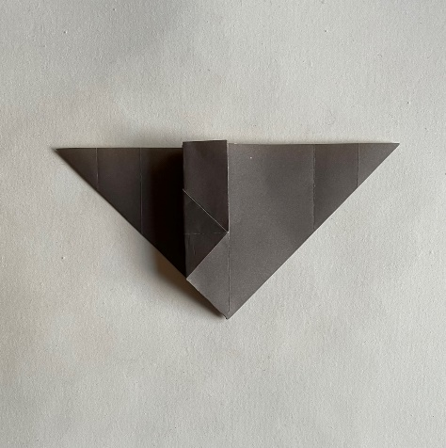 | Step 21 – Repeat the fold from the bottom point to the middle horizontal fold.  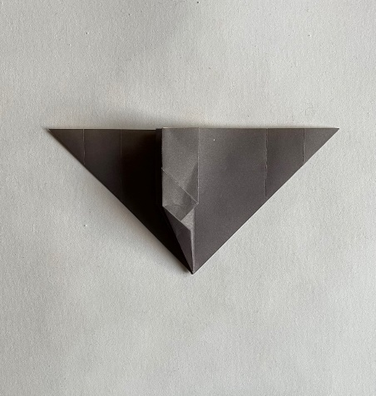
Step 22 – Turn this ‘page’ to the right to reveal the bat’s body.  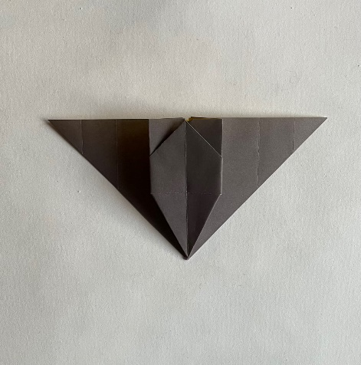 | Step 23 – Turn over and pull the front section down along the top horizontal fold.  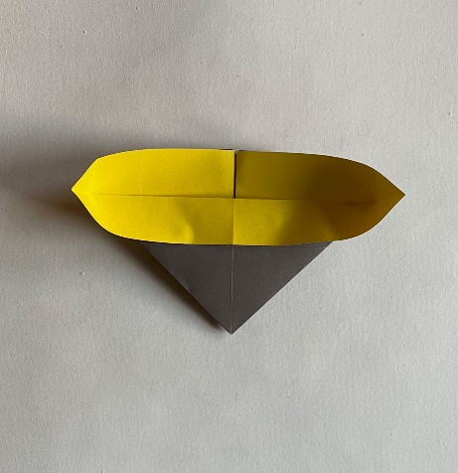 | Step 24 – Make two diagonal folds at the top centre for the ears, through all thicknesses of paper.  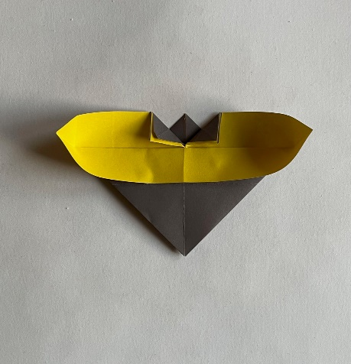
Step 25 – Push the diagonal folds back up, then fold down the left-hand side at the top.  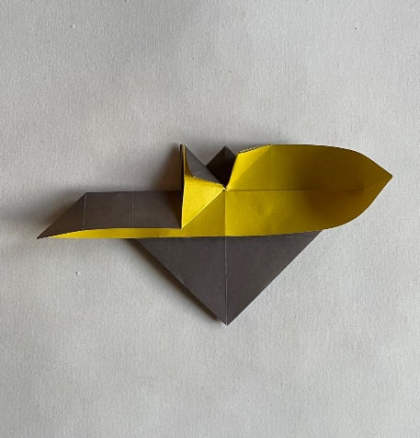 | Step 26 – Repeat on the right-hand side.  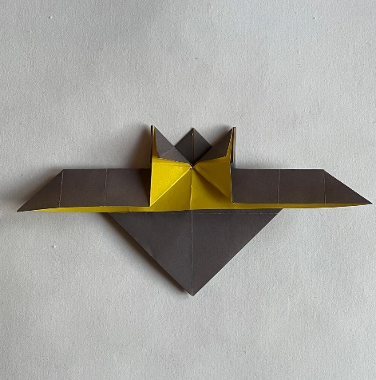 | Step 27 – Flip over to reveal your origami bat!  