Describing Transformations of Graphs
(a) | (b)
The graphs of $y=f(x)$ and $y=f\left(x\right)+a$ are shown below. Find the value of $a$.  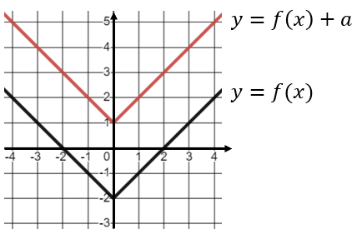 | The graphs of $y=\sin{x}$and $y=b\sin{(x)}$ are shown below. Find the value of $b$.  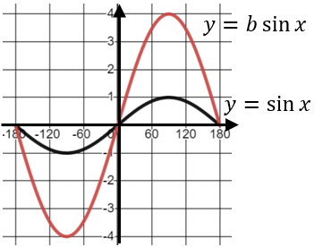
(c) | (d)
The graph of $y=f(x)$ is transformed to give the equation $y=-f\left(x\right)$. Describe the transformation in words. | The graph of $y=f(x)$ is transformed to give the equation $y=f\left(x-4\right)$. Describe the transformation in words.
(e) | (f)
The graph of $y=f(x)$ is transformed to give the equation $y=f\left(2x\right)$. Describe the transformation in words. | The graph of $y=f(x)$ is transformed to give the equation $y=f\left(-x\right)$. Describe the transformation in words.
(g) | (h)
The graph of $y=x^{2}$ has been transformed to give the graph shown below. Write down the equation of the transformed graph.  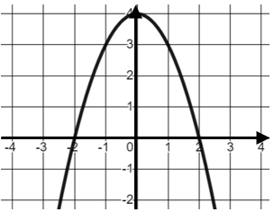 | The graph of $y=\cos{x}$ has been transformed to give the graph shown below. Write down the equation of the transformed graph.  