Piecewise Functions

Sketch the following functions:
(a) $f\left(x\right)=2 for -5≤x<0$
$$f\left(x\right)=2-x for 0≤x≤3$$
$$f\left(x\right)=-1 for 3<x≤5$$

(b) $f\left(x\right)=x for -4≤x<0$
$$f\left(x\right)=x^{2} for 0≤x≤4$$

(c) $f\left(x\right)=x^{2}+1 for -4≤x<0$
$$f\left(x\right)=1 for 0≤x≤2$$
$$f\left(x\right)=x-1 for 2<x≤4$$

(a) Given the graph of $y=f(x)$, define the function, stating the domain of each part clearly.
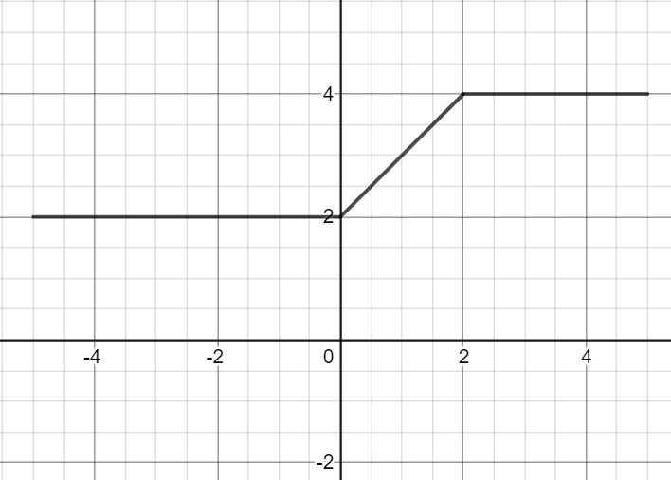
(b) Evaluate $f(1)$

(a) Given the graph of $y=f(x)$, define the function, stating the domain of each part clearly.
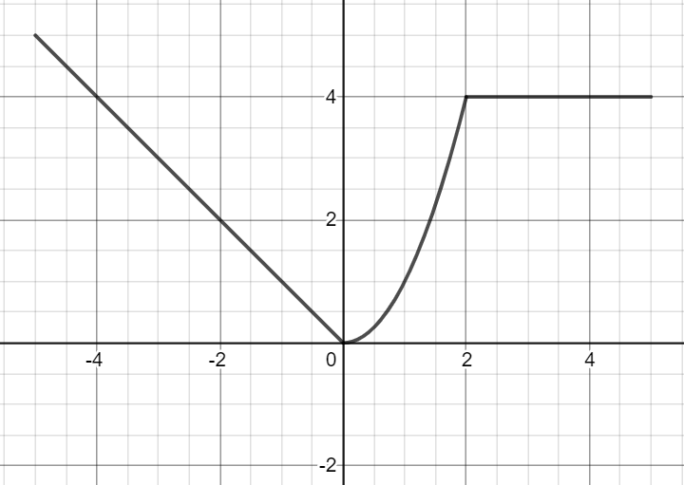
(b) Solve $f\left(x\right)=1$
Piecewise Functions

Sketch the following functions:
(a) $f\left(x\right)=2 for -5≤x<0$
$$f\left(x\right)=2-x for 0≤x≤3$$
$$f\left(x\right)=-1 for 3<x≤5$$

(b) $f\left(x\right)=x for -4≤x<0$
$$f\left(x\right)=x^{2} for 0≤x≤4$$

(c) $f\left(x\right)=x^{2}+1 for -4≤x<0$
$$f\left(x\right)=1 for 0≤x≤2$$
$$f\left(x\right)=x-1 for 2<x≤4$$

(a) Given the graph of $y=f(x)$, define the function, stating the domain of each part clearly.
(b) Evaluate $f(1)$

(a) Given the graph of $y=f(x)$, define the function, stating the domain of each part clearly.
(b) Solve $f\left(x\right)=1$

