Mixed Circle Theorems with Tangents
(a) | (b) | (c) | (d)
Find the size of angle $ABD$  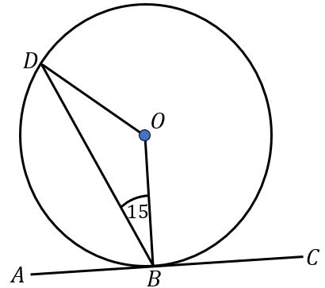 | Find the size of angle $EBA$  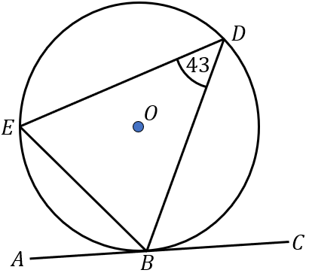 | Find the size of angle $ABC$  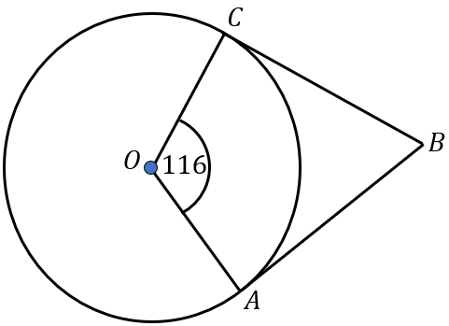 | Find the size of angle $BED$  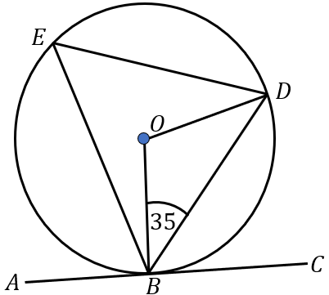
(e) | (f) | (g) | (h)
Find the size of angle $DEF$  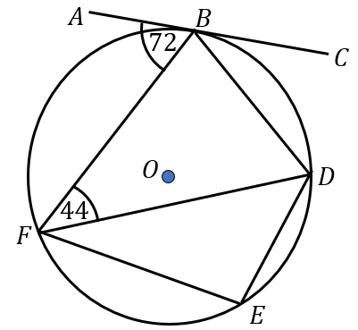 | Find the size of angle $BCD$  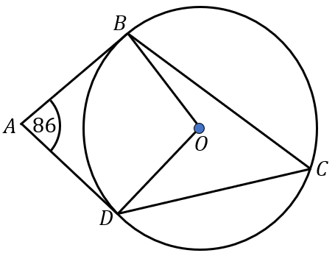 | Find the size of angle $DBC$  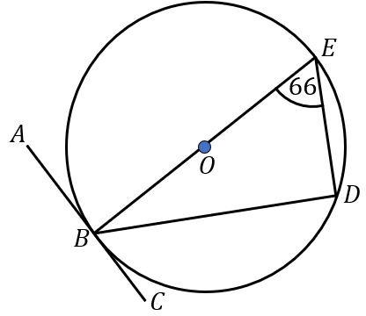 | Find the size of angle $ABE$  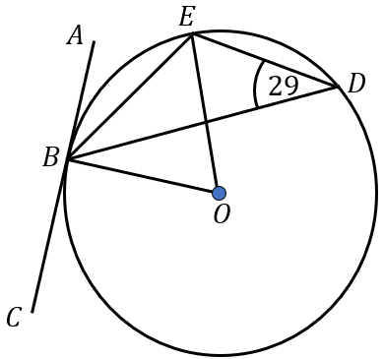
(i) | (j) | (k) | (l)
Find the size of angle $ADC$  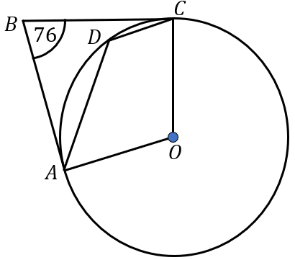 | Find the size of angle $EDC$  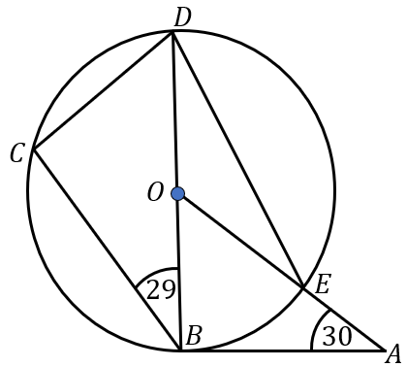 | Find the size of angle $DBC$  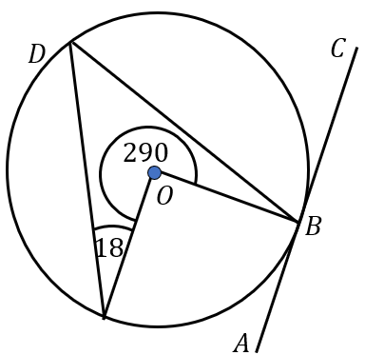 | Find the size of angle $FEB$  