Perimeter of 2D Shapes

Find the perimeter of each of these 2D shapes.
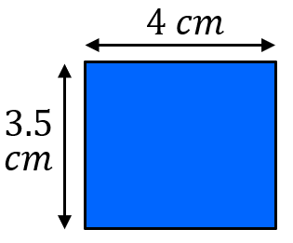
(a) $Rectangle$ (b) $Triangle$
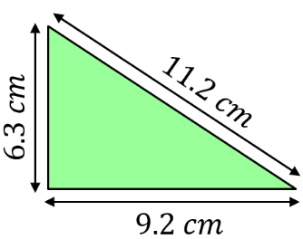

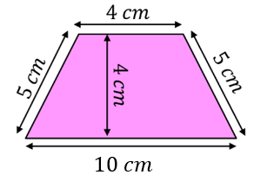
(c) $Trapezium$ (d) $Parallelogram$
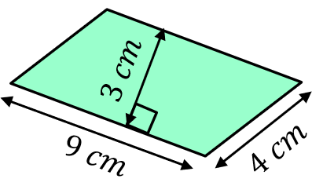

(e) $Rhombus$ (f) $Triangle$
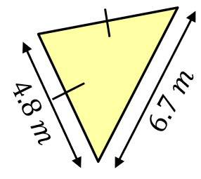
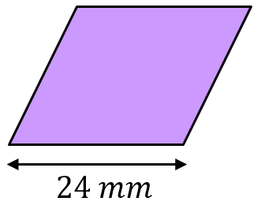

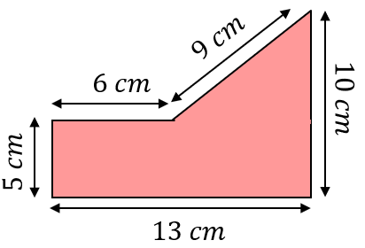
Find the perimeter of each of these 2D shapes.
(a) (b)
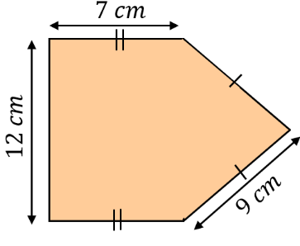

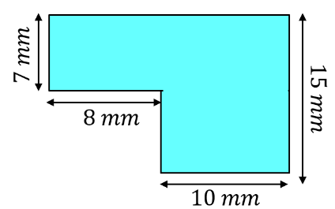
(c)

The perimeter of the shape is $31 cm$. Find the missing length $x$.
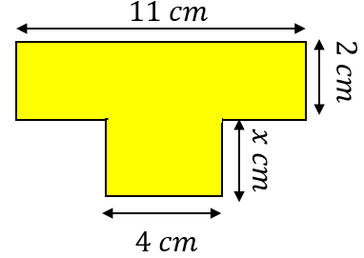

Perimeter of 2D Shapes

Find the perimeter of each of these 2D shapes.
(a) $Rectangle$ (b) $Triangle$

(c) $Trapezium$ (d) $Parallelogram$

(e) $Rhombus$ (f) $Triangle$

Find the perimeter of each of these 2D shapes.
(a) (b)

(c)

The perimeter of the shape is $31 cm$. Find the missing length $x$.

