Solving Quadratic Inequalities in Context
(a) | (b)
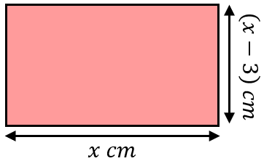  A rectangle has sides of length $x cm$ and width $(x-3) cm$, as shown. If the area of the rectangle is greater than $10 {cm}^{2}$:  (i) Show that $x^{2}-3x-10>0$  (ii) Find the range of possible values of $x$. | 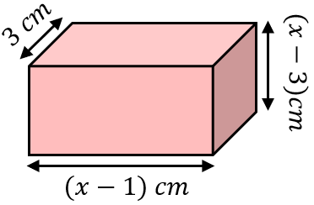  A cuboid has dimensions of $3 cm$, $(x-1) cm$ and $(x-3) cm$, as shown. If the volume of the cuboid is greater than$45 {cm}^{3}$:  (i) Show that $x^{2}-4x-12>0$  (ii) Find the range of possible values of $x$.
(c) | (d)
Given that the area of the rectangle is greater than the area of the triangle, find the range of possible values of $x$.  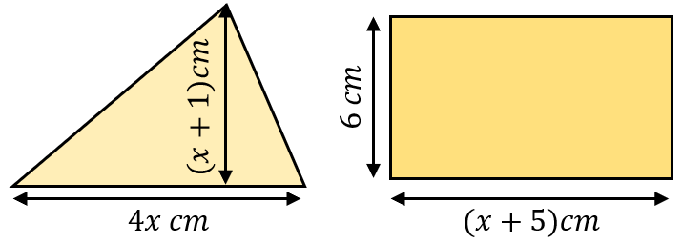 | 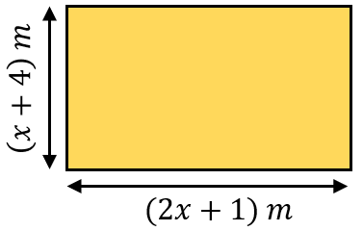  A rectangular lawn has a length of $\left(2x+1\right) m$ and a width of $\left(x+4\right) m$, as shown. Given that the area of the lawn is less than $49 m^{2}$, find the range of possible values of $x$.

