Areas of Semicircles and Quarter Circles
(a) | (b) |  | (c) |  | (d)
Find the area of a semicircle with a radius of $9$ cm | Find the area of a semicircle with a radius of $25$ mm |  | Find the area of a semicircle with a radius of $1.7$ m |  | Find the area of a semicircle with a diameter of $16$ cm
(e) | (f) |  | (g) |  | (h)
Work out the area of a quarter circle with a radius of $4.5$ cm | Work out the area of a quarter circle with a radius of $0.6$ m |  | Work out the area of a quarter circle with a radius of $26$ mm |  | Work out the area of a quarter circle with a diameter of $6$ cm
(i) | (j) |  | (k) |  | (l)
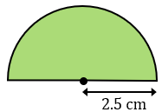  Calculate the area | 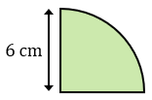  Calculate the area |  | 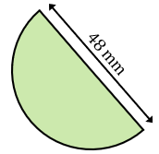  Calculate the area |  | 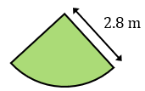  Calculate the area
(m) |  | (n) |  | (o)
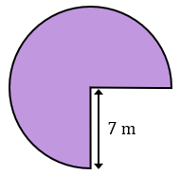  Calculate the area |  | 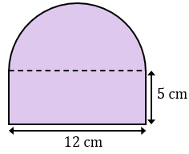  Calculate the area |  | 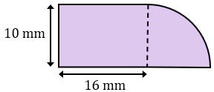  Calculate the area

