Forming and Solving Inequalities
- A rectangle has a width of $4 cm$ and a length of $\left(2x+3\right) cm$. The area of the rectangle is greater than $30 cm$. Form and solve an inequality in $x$.
- A rectangle has a width of $\left(y+1\right)cm$ and a length of $\left(4y-5\right) cm$. The length of the rectangle is more than twice its width. Form and solve an inequality in $y$.

- Wendy is $w$ years old. Xander is four years older than Wendy. Yuri is twice as old as Xander. When the ages of all three people are added together, their sum is at least $60$ years. Form and solve an inequality in $w$.
- Fred has $\left(t+14\right)$dollars. Gloria has $\left(2t+9\right)$ dollars. Hari has $\left(5t-9\right)$ dollars. Given that the amount of money Hari has is more than the amount of money Fred and Gloria have combined, form and solve an inequality in $t$.

(a) A triangle has side lengths $4x cm$, $\left(3x+2\right) cm$ and $\left(5-2x\right) cm$. The perimeter of the triangle is between $35 cm$ and $52 cm$. Form and solve a compound inequality in $x$.
(b) The compound shape shown has an area which is between $58 {cm}^{2}$ and $76 {cm}^{2}$. Form and solve a compound inequality in $y$. Given that $y$ is an integer, find its possible values.
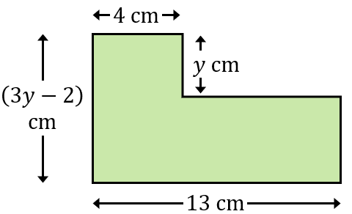
Forming and Solving Inequalities
- A rectangle has a width of $4 cm$ and a length of $\left(2x+3\right) cm$. The area of the rectangle is greater than $30 cm$. Form and solve an inequality in $x$.
- A rectangle has a width of $\left(y+1\right)cm$ and a length of $\left(4y-5\right) cm$. The length of the rectangle is more than twice its width. Form and solve an inequality in $y$.

- Wendy is $w$ years old. Xander is four years older than Wendy. Yuri is twice as old as Xander. When the ages of all three people are added together, their sum is at least $60$ years. Form and solve an inequality in $w$.
- Fred has $\left(t+14\right)$dollars. Gloria has $\left(2t+9\right)$ dollars. Hari has $\left(5t-9\right)$ dollars. Given that the amount of money Hari has is more than the amount of money Fred and Gloria have combined, form and solve an inequality in $t$.

(a) A triangle has side lengths $4x cm$, $\left(3x+2\right) cm$ and $\left(5-2x\right) cm$. The perimeter of the triangle is between $35 cm$ and $52 cm$. Form and solve a compound inequality in $x$.
(b) The compound shape shown has an area which is between $58 {cm}^{2}$ and $76 {cm}^{2}$. Form and solve a compound inequality in $y$. Given that $y$ is an integer, find its possible values.

