Investigating Similar Triangles
The five triangles drawn are similar right-angled triangles. This means that they have the same set of three angles, in this case $30°, 60°$ and $90°$.
(a) Label the sides of each triangle – H for hypotenuse, O for opposite and A for adjacent.
(b) Measure the lengths of each of the sides to the nearest mm, and fill into the table.
(c) Calculate the ratio of each pair of lengths using your calculator, to 2 decimal places.
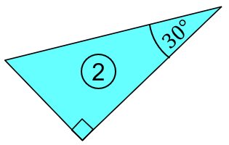
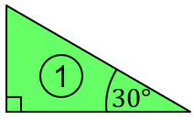
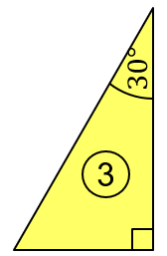

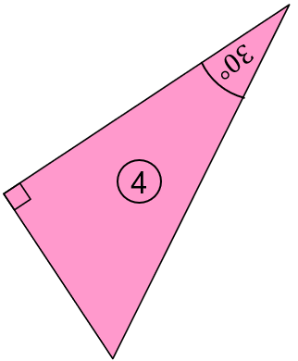

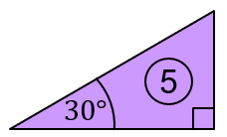

What do you notice?

Triangle | $$Opposite$$  $$(mm)$$ | $$Adjacent$$  $$(mm)$$ | $$Hypotenuse$$  $$(mm)$$ | $$\frac{Opposite}{Hypotenuse}$$ | $$\frac{Adjacent}{Hypotenuse}$$ | $$\frac{Opposite}{Adjacent}$$
1
2
3
4
5

