Investigating 3-D Shapes
There are five Plato’s solids – the tetrahedron, cube, octahedron, dodecahedron and icosahedron. They all have faces which are regular shapes.
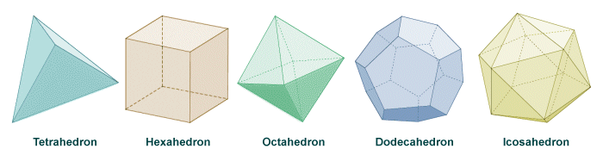
A 3-D shape has faces (surfaces), vertices (corners) and edges. Complete the table for the five 3-D shapes given.

3-D Shape | Shape of Face | No. of Faces | No. of Vertices | No. of Edges | Faces + Vertices
Tetrahedron
Cube
Octahedron
Dodecahedron
Icosahedron

What can patterns can you see in the table?

EULER’S FORMULA

Investigate whether Euler’s formula is true for other 3D shapes too.

